**Open Geospatial Consortium**

Submission Date: 2025-03-04

Approval Date:   2025-06-12

Publication Date:   <yyyy-mm-dd>

External identifier of this OGC® document: <[http://www.opengis.net/doc/[{doc-type/}]{standard}/{m.n}](http://www.opengis.net/def/%5b%7bdoc-type/%7d%5d%7bstandard%7d/%7bm.n%7d)>

Internal reference number of this OGC® document:    25-016

Category: OGC® Report

Editor:   Sylvain Grellet (BRGM), WaterQuality IE members

OGC Water Quality Interoperability Experiment Engineering Report

**Copyright notice**

Copyright © 2025 Open Geospatial Consortium  
To obtain additional rights of use, visit <https://www.ogc.org/ogc/Document>.

**License Agreement**

Permission for use/distribution of this document and any associated materials is subject to the terms of this License Agreement: <https://www.ogc.org/license>

**Warning**

This document is not an OGC Standard. This document is an OGC Public Engineering Report created as a deliverable in an OGC Interoperability Initiative and is not an official position of the OGC membership. It is distributed for review and comment. It is subject to change without notice and may not be referred to as an OGC Standard. Further, any OGC Engineering Report should not be referenced as required or mandatory technology in procurements. However, the discussions in this document could very well lead to the definition of an OGC Standard..

Document type:    OGC® Report

Document subtype:

Document stage:    Approved

Document language:  English

# Table of contents

Table of content 2

Table of figures 4

Revision history 93

1. Summary 7

1.1. Subject 7

1.2. Executive summary 7

1.3. Document contributor contact points 8

1.4. Future work 10

1.5. Foreword 11

2. Introduction 11

3. References 17

4. Terms, definition 17

5. Objectives 21

6. Use cases 22

6.1. Use case overview and prioritization 22

6.2. SurfaceWater In-situ Quantity Use Case 23

6.3. SurfaceWater In-Situ Quality Use Case 24

6.4. SurfaceWater Ex-Situ Quality Use Case 26

6.5. GroundWater In-Situ Quantity Use Case 28

6.6. GroundWater In-Situ Quality Use Case 29

6.7. GroundWater Ex-Situ Quality Use Case 31

7. Object Diagrams 32

7.1. Methodology 32

7.2. Reading Object Diagrams 34

7.3. In situ data patterns 35

7.3.1. In situ surface water quantity 35

7.3.2. In situ ground water quantity 38

7.3.3. In situ surface water quality 39

7.3.4. In situ ground water quality 41

7.4. Ex situ data patterns 42

6.4.1 Ex situ surface water quality 42

6.4.2 Ex situ ground water quality 45

8. Logical Model 46

8.1. Methodology 46

8.2. Additional Classes 46

9. Physical Model 47

9.1. Methodology 47

9.2. SensorThings / OMS mapping 49

9.3. SensorThings API deployment recommendations 50

10. Testing 51

10.1. North America 52

10.1.1. United States 52

10.1.2. Canada 53

10.1.3. Cross-border Interoperability Testing 54

10.2. France 55

10.2.1. In situ surface water quantity 55

10.2.2. Ex situ Surface water quality 56

10.2.3. In situ ground water quantity and quality 57

10.2.4. Ex situ Ground water quality 59

10.3. UNEP - GEMS 59

10.4. EU EEA 59

10.5. Water4All members testing 62

10.6. Cross-testing and data exchange 65

10.6.1. Across countries / organisations 65

10.6.2. Across tools 69

11. Findings and standing issues 74

11.1. Findings 74

11.2. Standing issues 74

11.3. Impact on external standards 75

12. Conclusions 77

13. Acknowledgments 77

14. Acronym table 78

15. Annex A: other examples of Surface Water In-situ Quantity Use Case 79

16. Annex B: other examples of Surface Water In-situ Quality Use Case 83

17. Annex C: other examples of Surface Water Ex-situ Quality Use Case 84

18. Annex D: other examples of Ground Water In-situ Quality Use Case 87

19. Annex E: other examples of Ground Water Ex-situ Quality Use Case 87

20. Annex F: WQX mapping to WQ IE 89

21. Annex G: SensorThings API 1.1 + WQ IE extension payload example 89

22. Annex H: French Sandre mapping to WQ IE 92

22.1. In-situ surface water quantity 92

22.2. Ex-situ surface water quality 92

22.3. In-situ ground water quantity/quality 92

22.4. Ex-situ Ground water quality 92

23. Annex I: EEA WISE SoE mapping to WQ IE 93

24. Annex I: I-ADOPT Fresh Water Observable properties 93

25. Annex K: Water Quality IE Deployment Documentation 93

# Table of figures

Figure 1 – Generic water quality sample and observation workflow 12

Figure 2 – Cross-border USA/Canada water quality observation with WQX 13

Figure 3 – Australia’s Watr Data Online portal 13

Figure 4 – French Ground Water quality observation context 14

Figure 5 – French Surface Water quality observation context 14

Figure 6 – Land Baden-Württemberg water portal 15

Figure 7 – Water Quality reporting in Europe 16

Figure 8 – UNEP GEMS Water portal 16

Figure 9 – Example of sensor equipped surface water quantity in-situ monitoring site 24

Figure 10 – Example of manual surface water quantity in-situ monitoring 24

Figure 11 – Example of sensor equipped surface water quality in-situ monitoring site. 25

Figure 12 - surface water quality in-situ, multi-parameter probes, temperature and dissolved oxygen sensors (USGS) 26

Figure 13 – Example of surface water quality sample for ex-situ analysis 27

Figure 14 – Example of surface water quality sub-sampling for ex-situ analysis. 27

Figure 15 – Example of surface water quality samples for ex-situ lab analysis. 28

Figure 16 – Example of sensor equipped ground water quantity in-situ monitoring site. 29

Figure 17 - Example of manual ground water quantity in-situ monitoring. 29

Figure 18 – Example of sensor equipped ground water quality in-situ monitoring site. 30

Figure 19 – Example of well pump house instrumentation of for measuring in-situ groundwater quality properties. 31

Figure 20 – Example of surface water quality sample for ex-situ analysis. 32

Figure 21 – First Use case drawings 33

Figure 22 - Use case grouping into two main data patterns 33

Figure 23 – Object diagram example 35

Figure 24 – In situ surface water quantity single observation 36

Figure 25 – In situ surface water quantity single observation (simplified) 36

Figure 26 – In situ surface water quantity timeseries observation 37

Figure 27 – In situ surface water quantity timeseries observation (simplified) 37

Figure 28 – In situ ground water quantity single observation 38

Figure 29 – In situ ground water quantity timeseries observation 39

Figure 30 – In situ surface water quality single observation 40

Figure 31 – In situ surface water quality timeseries observation 40

Figure 32 – In situ ground water quality single observation 41

Figure 33 – In situ ground water quality timeseries observation 42

Figure 34 – Ex situ surface water quality single observation 43

Figure 35 – Ex situ surface water quality sampling context 44

Figure 36 – Ex situ surface water quality timeseries Dissolved Oxygen observation 44

Figure 37 – Ex situ surface water quality timeseries pH observation 45

Figure 38 – Ex situ ground water quality sampling act and associated observation 46

Figure 39 – Water Quality IE Logical Model 47

Figure 40 – STA 2.0 WQ IE draft 50

Figure 41 – example WQ IE data integration in US Internet of Water HubKit in a box tool. 55

Figure 42 – 2 French surface water in-situ water quantity and ex-situ water quality stations on the Dordogne river 56

Figure 43 – Accessing the available datastreams of twoFrench surface water in-situ water quantity and ex-situ water quality stations on the Dordogne river 56

Figure 44 - Surface Water Quality Ex-Situ readings at “La Dordogne à Cenac” station 57

Figure 45 -Surface Water In-situ Quantity readings at “La Dordogne à Cénac et Saint-Julien Station” 57

Figure 46 – GPRS Fitted Ground Water In-Situ Quantity and In-Situ Quality stations near Orléans 58

Figure 47 – Accessing Ground Water In-Situ Quantity and In-Situ Quality readings 58

Figure 48 – Overview of EU EEA WISE SoE - Water Quality (WISE-6) exposed using WQ IE recommendations 60

Figure 49 – Accessing a station description from EU EEA WISE SoE - Water Quality (WISE-6) using WQ IE approach 61

Figure 50 – Accessing a observations from a EU EEA WISE SoE - Water Quality (WISE-6) reported station using WQ IE approach 62

Figure 51 – Danish Environmental Portal water quality/quantity stations 63

Figure 52 -ISPRA water surface water Ex-situ quality stations (pesticide database) 63

Figure 53 – Available Datastreams at one Surface water quality Ex-Situ station from ISPRA’s pesticides database 64

Figure 54 – Bentazone concentration evolution at a given Surface water Ex-Situ quality station 64

Figure 55 - French and German Surface water Ex-situ Quality stations on both sides of the Rhine river 65

Figure 56 – Accessing Datastreams about the same observerdProperty at nearby French and German stations 66

Figure 57 – Two French and German Surface water Ex-Situ quality stations of interest 66

Figure 58 – Illustrating the need to align/link vocabularies across organisations (Nitrate example) 67

Figure 59 – Illustrating the need to align/link vocabularies across organisations (DDT example) 67

Figure 60 – French Surface water In-Situ quantity in WHOS 68

Figure 61 – Accessing readings from a French Surface water In-Situ quantity station in WHOS 68

Figure 62 – French Ground and Surface water In-Situ data in WHOS 69

Figure 63 – WMO feedback on the feasibility to connect to French data using the WQ IE recommended practices during a WMO workshop 69

Figure 64 – Surface water quality data US - Canada, Great Lakes region in WebGenesis 70

Figure 65 – French data: raw in-situ groundwater quantity & quality in WebGenesis 71

Figure 66 – Accessing WQ IE selected North America test regions stations in US Internet of Water tool 71

Figure 67 – Accessing available DataStreams from one German Surface Water Ex-Situ Station in QGIS 72

Figure 68 – Accessing available Observations from one German Surface Water Ex-Situ Station in QGIS 73

Figure 69 - Accessing USGS and US WQP stations through WQ IE recommendations in R studio 73

# Summary

## Subject

This OGC document reports on an Interoperability Experiment (IE) aimed at creating the necessary semantic and technical framework for water quality data exchange. Water quality is one of the United Nations Sustainable Development Goals (SDGs)[1] and is one of the main challenges that societies will face during the 21st century, threatening human health, limiting food production, reducing ecosystem functions, and hindering economic growth.

Many countries and organizations do acquire and exchange data related however, there is an international lack of a shared standard to achieve which complexifies the effort.

In 2022, the WMO, UNEP, UNESCO, WHO, OGC co-organized a Workshop Series on Water Quality Monitoring hosted under the banner of the World Water Quality Alliance (WWQA) to foster the development and operationalization of innovative solutions for water quality monitoring, improve data harmonization and interoperability, and arrive at a common roadmap for strengthened cooperation on water quality monitoring across the various institutions and data streams. This Interoperability Experiment is one of the main actions decided during that Workshop Series.

Through use cases encompassing the facets covered by the term “Water Quality” as well as associated data (water quantity), the exercise enabled to identify common patterns building on the OGC standards baseline for water quality data sharing and to implement and test those standards across various organizations and tools.

## Executive summary

This document reports on an exercise involving several government organizations, private companies, and academics, trying to harmonize water quality data exchange.

Water quality encompasses several notions that needed to be clarified and prioritized so that clear work could be undertaken. Building on the identified use cases, a clarification of the information elements (concepts) that are necessary for water quality data exchange was carried out. All that work builds on the OGC Baseline for its semantic part, leveraging “Observations, Measurements and Samples” (OGC 20-082r4), “OGC® WaterML 2: Part 3 – Surface Hydrology Features (HY_Features) – Conceptual Model 1.0” (OGC 14-111r6), and “OGC WaterML 2: Part 4 – GroundWaterML 2 (GWML2) 2.2” (OGC 16-032r2). As those standards already covered the need, most of the effort was to illustrate and document how to use the standards in combination to achieve the target goals.

The next step involved technical assessment of the OGC Baseline so that the most relevant OGC APIs are identified for implementation. “OGC SensorThings API Part 1: Sensing Version 1.1” (OGC 18-088) was the obvious choice as the core focus was on observation exchange. Its model was enhanced including evolutions brought by the “Observations, Measurements, and Samples” revision to meet the conceptual exercise requirements (thus paving the way for the V2 of SensorThings API Part 1).

All the necessary framework was then available for the Interoperability Experiment members to implement the approach on top of their respective systems opening allowing for various testing environments across countries, organizations, and tools. This testing validated the proposed solutions in concrete environments.

Future work was identified to settle the approach for the community to build on. This work includes some standing issues but mainly targets evolution in relevant identified standards as described in section 1.4 “Future work”.

This report includes several illustrations from the modelling exercise that are available from the online OGC Enterprise Architect tool (<https://umltool.ogc.org/> ), as well as from the data exchange testing. It also contains references to content that is publicly available on the Water Quality IE (WQ IE) GitHub repository (<https://github.com/opengeospatial/WaterQualityIE> ).

## Document contributor contact points

All questions regarding this document should be directed to the editor or the contributors:

|  |  |
| --- | --- |
| Name | Organization |
| Sylvain Grellet | BRGM |
| Kyle Onda | Lincoln Institute of Land Policy |
| Kathi Schleidt | DataCove e.U. |
| Hylke van der Schaaf | Fraunhofer IOSB |
| Lee Stanish | U.S. Geological Survey |
| Candice Hopkins | U.S. Geological Survey |
| Meghan McLeod | Datastream |
| Kevin Christian | US EPA |
| Cristina Mullin | US EPA |
| Adam Griggs | US EPA |
| Philipp Saile | UNEP GEMS/Water Data Centre, ICWRGC, Federal Institute of Hydrology (BfG) |
| Tony Boston | Australian National University |
| Ben Webb | Lincoln Institute of Land Policy |
| Lucas Valarcher | BRGM |
| Hélène Bressan | BRGM |
| Lindsay Day | DataStream |
| Washington Otieno | World Meteorological Organisation |
| Abdelfettah Feliachi | Infeurope |

## Future work

The group recognized that part of more formal work should be undertaken under the umbrella of the OGC Hydro Domain Working Group (OGC Hydro DWG) and potentially by an OGC Standards Working Group (SWG) directly linked with the Hydro DWG in the case a standard is to be produced / updated.

Direct water quality specific recommendations from this IE are to:

* Support the finalization of the current update of OGC SensorThings API Part 1 V 1.1 into a V2 building on this IE (and the Geotech IE exercise)
* Update the current “WaterML-WQ – an O&M and WaterML 2.0 profile for water quality data” <https://docs.ogc.org/bp/14-003/14-003.html> and formalize it as a WaterML 2.0 Part 5 - Best Practice document for Water Quality Data Exchange

This exercise was also the opportunity to review water timeseries exchange for in-situ water quality data exchange but also for in-situ water quantity data exchange. It proved that the same approach based on OGC/ISO ISO 19156:2023: Observations, Measurements and Samples (OMS) and OGC SensorThings API Part 1 was working for those data both on the data provision and client sides. Some organizations working in production with the current OGC® WaterML 2.0: Part 1- Timeseries (OGC 10-126r4) are also already testing using SensorThings API for such data exchange and decommission the OGC Sensor Observation Services.

As such, “derived” recommendations from this study are to:

* Update OGC® WaterML 2.0: Part 1- Timeseries 10-126r4 with regards OMS update and current work currently happening within OGC on “Timeseries Profile of Observations and Measurements” (OGC 15-043r3); and
* Potentially develop an OGC document (the form of which is yet to be defined) between a Standard and a Best Practice framing how such Timeseries could be exchanged using OGC SensorThings API

## Foreword

Attention is drawn to the possibility that some of the elements of this document may be the subject of patent rights. The Open Geospatial Consortium shall not be held responsible for identifying any or all such patent rights.

Recipients of this document are requested to submit, with their comments, notification of any relevant patent claims or other intellectual property rights of which they may be aware that might be infringed by any implementation of the standard set forth in this document, and to provide supporting documentation.

# Introduction

The category of “water quality data” can represent many measurements that help to define the properties of water at the time of measurement. Measurements of water quality are often taken to measure the suitability of water for a particular use based on physical, chemical, or biological characteristics. Assessing water quality measurements can help to determine if water is suitable for drinking, for wildlife, or for recreation, such as swimming, boating, or fishing. Water quality measurements are often associated with measurements of water quantity; together, these two pieces of information ascertain the overall availability of water.

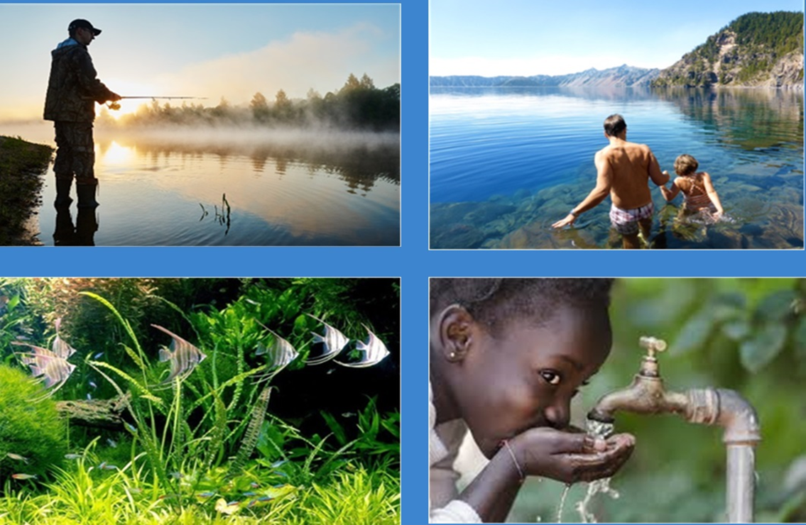

Collecting water quality data ranges from simple - such as filling a bottle with water - to complex - such as setting up sampling instrumentation or sampling with specialized equipment for trace contaminants. Regardless, the process generates complex data and supporting metadata. Samples are first collected in the field: these samples may be focused on physical and chemical aspects of the water, the biota, or the surrounding environment such as sediment or air. A sample may be analyzed in the field or taken off-site for analysis in a laboratory. Often, samples undergo field processing or preservation. Water quality data can also be collected by a sensor that is either installed in place and collects data continuously and autonomously, or in discrete instances. Metadata including sampling method, processing steps, conditions at the time of sampling, and other spatial and temporal metadata are essential in understanding data generated through analysis.

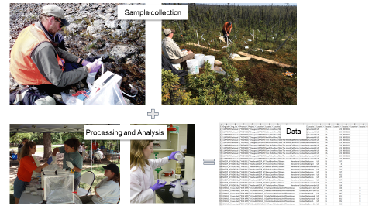

Figure 1 – Generic water quality sample and observation workflow

Across the globe, water quality data are collected and shared by organizations, agencies, governments, companies, and communities. Data may be collected at various administrative levels, such as an individual water body, region, state, or country. Additionally, methods of sharing data vary greatly and are often localized and occur on an ad-hoc basis, such as with colleagues or within an agency. Some data collectors make data more widely available: they might share files in a final report, in a publication, or use public-facing APIs and web services. A major challenge is that the underlying data model for storing water quality data and vocabularies used within these data models can vary greatly and hinder comparisons across data sets. Furthermore, there is no globally followed standard data model or vocabulary, meaning that each organization may store different attributes of results and metadata and may use unique or imprecise vocabulary. The differences in data storage, delivery, and vocabulary make it difficult, if not impossible, to aggregate data from disparate sources.

Various water quality data portals and initiatives exist in different parts of the world aiming to ease the data aggregation process:

* In North America the Water Quality eXchange (WQX) schema is used by the United States and Canada to aggregate data from many organizations into a common format. This schema, developed by the U.S. Environmental Protection Agency and used in data delivery services such as the Water Quality Portal (operated by the United States Geological Survey), defines required fields that are necessary for comprehensive data exchange. DataStream, a nongovernmental organization in Canada, has built its schema (DS-WQX), based on the WQX data format.

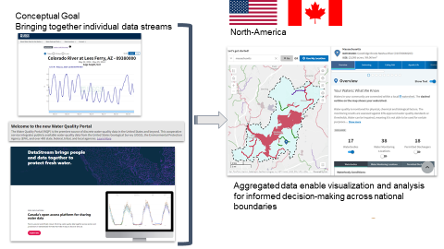

Figure 2 – Cross-border USA/Canada water quality observation with WQX

* In Australia, water quantity and quality data from monitoring sites managed by state and territory agencies are aggregated via a common format into a national portal (Water Data Online) through which they are available for map and graph visualization, and download.

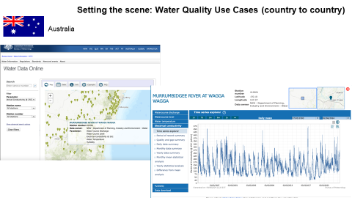

Figure 3 – Australia’s Water Data Online portal

* In France, data structures & vocabulary (semantics) and data transfer (web services) are French specific (<https://sandre.eaufrance.fr/>). For both ground and surface water, data providers are providing their data according to those national specifications. Data are then aggregated in specific portals as summarized below.

The French ground water bank ‘ADES’ is fed data from Water Agencies, the French Geological Survey (BRGM), various ministries and partners using the national ad hoc specifications.

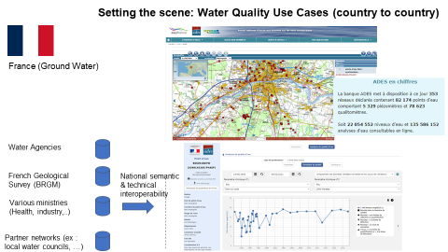

Figure 4 – French Ground Water quality observation context

The French surface water quality bank ‘Naïades’’ is fed data from Water Agencies, the French Biodiversity Office (OFB) and various partners using the national ad hoc specifications.

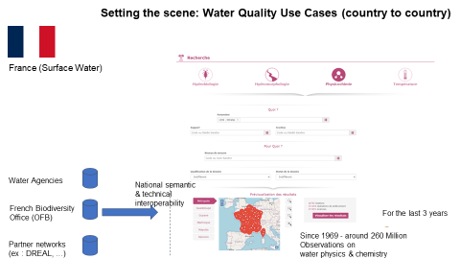

Figure 5 – French Surface Water quality observation context

* In Germany the responsibility for monitoring water quality lies with each member state separately. The result is that each member state has its own system for managing water quality management, with its own data models. There is some effort to harmonize key lists, like observed properties, but this harmonization is not complete. Each member state also has its own way of publishing water quality data. The image below shows the website used by the state of Baden-Württemberg (LUBW).

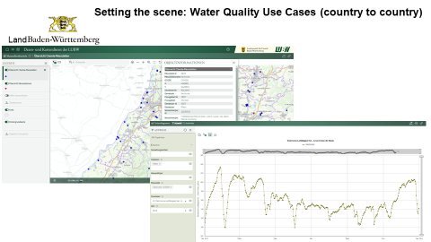

Figure 6 – Land Baden-Württemberg water portal

* At the overall Europe level, EU Member States report data to the EU level regarding many environmental directives (including water). The reporting schemas are defined at EU level. Recently there has been an effort into having some of them getting closer to standards. Only the WISE SoE (Water Information System for Europe - State of the Environment) data reporting actually contains water observation. The other water reporting targets sharing monitoring programmes, station, network, waterbodies (a management unit), and monitored river basin.

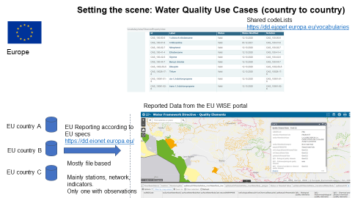

Figure 7 – Water Quality reporting in Europe

* At the international level, the Global Environment Monitoring System for Freshwater (GEMS/Water) of the United Nations Environment Programme (UNEP) has been working on supporting UN Member States in building their water quality monitoring capacities and compiles a global database.

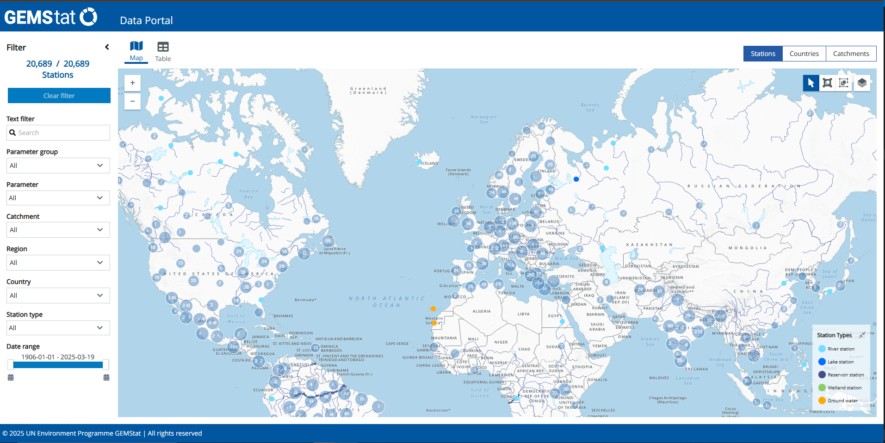

Figure 8 – UNEP GEMS Water portal

This scattered scenario complexifies analysis of the state of the (water) environment thus the set up of the necessary actions to ensure global water quality.

# References

- OGC/ISO ISO 19156:2023: Observations, Measurements and Samples (OGC 20-082r4),

- OGC SensorThings API Part 1: Sensing Version 1.1 (OGC 18-088) [OGC SensorThings API Part 1: Sensing Version 1.1](https://docs.ogc.org/is/18-088/18-088.html),

- “WaterML-WQ – an O&M and WaterML 2.0 profile for water quality data” <https://docs.ogc.org/bp/14-003/14-003.html>,

- OGC® WaterML 2.0: Part 1- Timeseries 2.0.1 (OGC 10-126r4): <https://www.ogc.org/publications/standard/waterml/>,

- OGC on “Timeseries Profile of Observations and Measurements” (OGC 15-043r3), also known as TimeseriesML <https://www.ogc.org/publications/standard/tsml/>,

- OGC® WaterML 2: Part 3 – Surface Hydrology Features (HY_Features) – Conceptual Model 1.0 (OGC 14-111r6),

- OGC WaterML 2: Part 4 – GroundWaterML 2 (GWML2) 2.2 (OGC 16-032r2),

- OGC / W3C Recommendation Semantic Sensor Network Ontology: <https://www.w3.org/TR/vocab-ssn/> , also known as SSN/SOSA.

# Terms, definition

The following terms and definitions have been taken from [**OGC Abstract Specification Topic 20: Observations, measurements and samples**](https://docs.ogc.org/as/20-082r4/20-082r4.html#_terms_and_definitions)**,** [**OGC SensorThings API Part 1: Sensing Version 1.1**](https://docs.ogc.org/is/18-088/18-088.html)and extended with examples specific to the water quality domain.

**datastream**

A Datastream groups a collection of Observations measuring the same ObservedProperty and produced by the same Sensor**.**

***deployment***

A Deployment shall be defined as information on the assignment of an Observer to a Host.

**domain**

well-defined set

**domain feature**

feature of a type defined within a particular application domain

**ex situ**

off-site

referring to the study, maintenance or conservation of a specimen or population away from its natural surroundings. EXAMPLE Svalbard Global Seed Vault

**feature**

abstraction of real-world phenomena

**feature type**

class of features having common characteristics

**feature-of-interest**

subject of the observation

EXAMPLE: a transect of the Rhine river being monitored for its water quality or the station that does this monitoring

**host**

A Host shall be defined as a grouping of Observers for a specific reason. In many use cases, the Host is the environmental monitoring facility. The Host can be a platform that hosts a set of sensors. An alternative usage could pertain to a biodiversity survey campaign. In this scenario, the team performing the survey would be modelled as observers whereas the entire survey campaign can be represented as a Host. [OMS 3 8.7.2]

**in situ**

on-site

referring to the study, maintenance or conservation of a specimen or population without removing it from its natural surroundings

EXAMPLE typically referring to sensor-based water quality observations that are limited to a small number of observed properties including water temperature, dissolved oxygen, ammonium, nitrate, chloride, electrical conductivity, pH, ORP, total dissolved solids, total suspended solids

**measure**

<GML> value described using a numeric amount with a scale or using a scalar reference system

**measurement**

set of operations having the object of determining the value of a quantity

**observable property**

a quality (property, characteristic) of the feature-of-interest that can be observed [OMS 3 8.3.2]

**observation**

act carried out by an observer to determine the value of an observable property of an object (feature-of-interest) by using a procedure, with the value provided as the result

**observation collection**

a collection of similar Observations

**observation result**

estimate of the value of a property determined through a known observation procedure

EXAMPLE dissolved oxygen concentration measured through an optical dissolved oxygen sensor

**observer**

identifiable entity that can generate observations pertaining to an observable property by implementing a procedure

EXAMPLE a water quality sensor measuring dissolved oxygen or a laboratory technician applying a laboratory analytical method such as 4500-O C. Azide Modificationto determine dissolved oxygen concentration from a water sample

***observing capability***

information on Observation(s) that could potentially be provided.

**observing procedure**

the description of steps performed in order to determine the value of an observableProperty by an Observer. [OMS 3 8.5.2]

**OMS**

Observations, Measurements and Samples, version 3 of OGC O&M, version 2 of ISO 19156

**procedure**

specified way to carry out an activity or a process

**preparation procedure**

the description of preparation steps performed on a Sample

**preparation step**

**property**

facet or attribute of an object referenced by a name

**proximate feature-of-interest**

entity that is directly of interest in the act of observing

EXAMPLE: a station monitoring the Rhine river for its water quality

**range**

<coverage> set of feature attribute values associated by a function, the coverage, with the elements of the domain of a coverage

**sample**

object that is representative of a concept, real-world object or phenomenon

EXAMPLE Water sample taken from a waterbody to determine the value of an observable property using a laboratory analysis method

**sample collection**

a collection of Samples

**sampler**

device or entity (including humans) that is used by, or implements, a sampling procedure to create or transform one or more sample(s)

EXAMPLE Automatic water sampler for discrete grab samples

**sampling**

an object that is representative of a concept, real-world object or phenomenon [OMS 3 11.2.2]

EXAMPLE 6 Extracting a sample from a defined environmental monitoring station.

**sampling procedure**

the description of steps performed by a Sampler in order to extract a Sample from its sampledFeature in the frame of a Sampling [OMS 3 11.7.2]

**sensor**

element of a measuring system that is directly affected by a phenomenon, body, or substance carrying a quantity to be measured

EXAMPLE dissolved oxygen optical sensor

**thing**

an object of the physical world (physical things) or the information world (virtual things) that is capable of being identified and integrated into communication networks [ITU-T Y.2060]

**ultimate feature-of-interest**

entity that is ultimately of interest in the act of observing

EXAMPLE: a transect of the Rhineriver being monitored for its water quality by a water quality station (proximate feature-of-interest)

**unit of measure**

reference quantity chosen from a unit equivalence group

EXAMPLE milligram per litre (mg/L)

**value**

element of a type domain

# Objectives

The goals of the IE are as follows.

1. Create a water quality observation model leveraging on the current OGC baseline for semantics
2. Map the model to those existing in organizations/countries.
3. Identify API(s) of choice to exchange such data leveraging on the current OGC baseline for APIs.
4. Test the corresponding exchange on various Use Cases and report back to the community .

# Use cases

Water Quality IE participants cover a wide diversity of sub-domains directly related to the notion of Water Quality.

The scoping exercise was driven by use cases from IE participants and also the type of water related information they have access to.

This helped involved parties find common ground and semantic concepts for discussion, the result of which is the proposed Water quality/quantity model.

## Use case overview and prioritization

From the inception it was clear that, to address water quality, water quantity data was necessary to be exchanged. Water quantity was added as a support to Water Quality.

After a first version separating Surface water from Ground water use case it was also decided that the Feature Of Interest (FoI) type could be merged when identifying use cases. This was considered of minimal impact with regards to the information model and API from previous prototyping experience by some IE members. Thus, the use case identification was done regardless of surface/ground water.

The following table provides an overview of all aspects of water quality information:

|  |  |  |  |  |
| --- | --- | --- | --- | --- |
| *Observed Property group* | Quantity | Physical properties | Chemistry | Biology |
| In situ sensor | Here as a support to WaterQuality | (1) | (2) |  |
| Ex situ (lab analysis) |
| Models |  |  |  |  |
| Remote |  |  |  |  |

Table 1 – Use Case matrix

The following table summarizes the grouping of use cases the IE members agreed on carrying out:

|  |  |  |  |  |
| --- | --- | --- | --- | --- |
|  | Surface Water | | Ground Water | |
|  | In situ | Ex situ | In situ | Ex situ |
| Quality | ☑ | ☑ | ☑ | ☑ |
| Quantity | ☑ | ☒ | ☑ | ☒ |

Table 2 – Selected Use Cases

With regards to the available IE members data as well as the current availability of clear guidelines to exchange surface/ground water quantity/quality data use cases were prioritized as follows:

* (1) In-situ - Physical Properties (ex: Temperature, Conductivity),
* (2) Chemistry, and
* Water quantity was taken on-board as a support to interpret Water Quality data.

Several identified use cases have been considered out of scope of this current IE. They would natively be good candidate for a follow up IE:

* Biology (taxa observation, community),
* Hydro Models, and
* Remote Sensing.

## SurfaceWater In-situ Quantity Use Case

The Surface Water In-situ Quantity Use Case corresponds to the installation of sensors in a fixed location that measure the height of the water (e.g., stage) or manual measurements done at specific locations (ex: manual measurements of quantity - often to complete a model to correlate stage to discharge).

These are deployed at ideal locations within the stream to capture flow over a wide range of conditions (baseflow, low flow, flood, etc.). Stage data are used to compute stream discharge based on a manually acquired relationship between stage and discharge (e.g., rating curve).

To be able to use in situ water quantity data, users must know various information about the sensor itself, including location (latitude, longitude, altitude), the type of sensor (this relates to measurement accuracy and reliability), and whether there are other measured properties associated with that sensor. For the measurement observations, users need to know when the measurement occurred (date/time/time zone), sampling procedures, and measurement units.

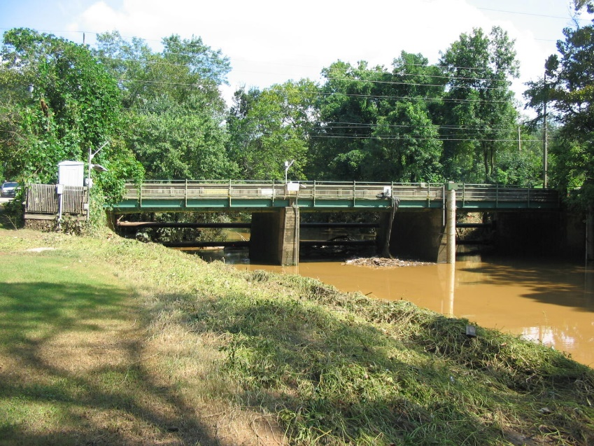

Figure 9 – Example of sensor equipped surface water quantity in-situ monitoring site

[Peachtree Creek WaterWatch, Atlanta, Ga. water monitoring site (USGS)](https://www.usgs.gov/media/images/peachtree-creek-waterwatch-atlanta-ga-water-monitoring-site)

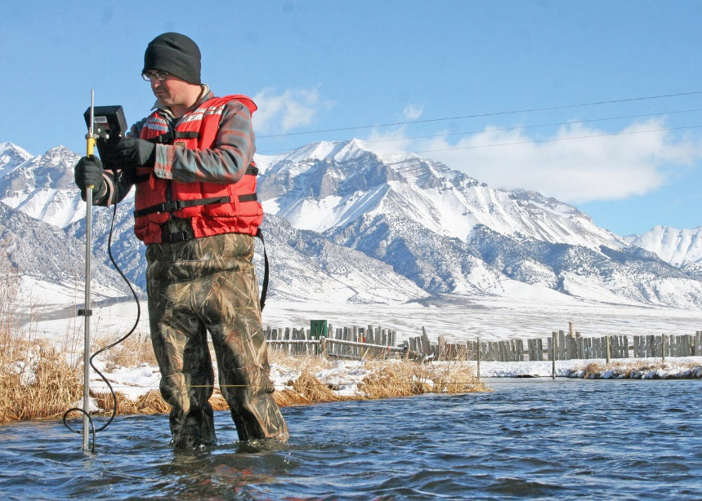

Figure 10 – Example of manual surface water quantity in-situ monitoring

[USGS hydrographer measuring streamflow on Warm Springs Creek, Idaho (USGS)](https://www.usgs.gov/media/images/usgs-hydrographer-measuring-streamflow-warm-springs-creek-idaho)

Other illustrative examples are available in “Annex A: other examples of Surface Water In-situ Quantity Use Case.”

## SurfaceWater In-Situ Quality Use Case

Surface water in-situ quality refers to observation data acquired on site regarding observable properties such as temperature, conductivity, pH, dissolved oxygen, nitrogen species (nitrate, nitrite, ammonium), and phosphate. Measurements are conducted by deploying different sensors either stationary at various depths on buoys or other structures in rivers or lakes, or temporarily during sampling activities. Most existing sensors use optical (colorimetric, fluorescence), electrochemical (potentiometric, amperometric) and electric sensing methods. These sensors require periodic maintenance such as calibration, record correction and cleaning.

Some in-situ measurements are also taken without sensors (test strips, sechhi disks, etc.).

To be able to use in situ water quality data, users must know various information about the sensor itself, including location (latitude, longitude, altitude), the type of sensor or equipment (this relates to measurement accuracy and reliability), and whether there are other measured properties associated with that sensor.

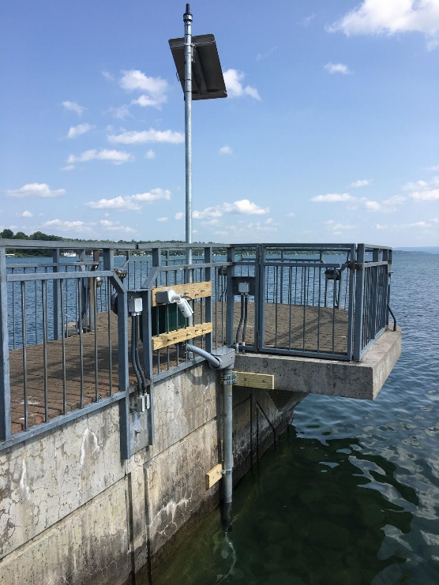

Figure 11 – Example of sensor equipped surface water quality in-situ monitoring site.

[Pier water quality monitoring station at Skaneateles Lake (USGS)](https://www.usgs.gov/media/images/pier-water-quality-monitoring-station-skaneateles-lake)

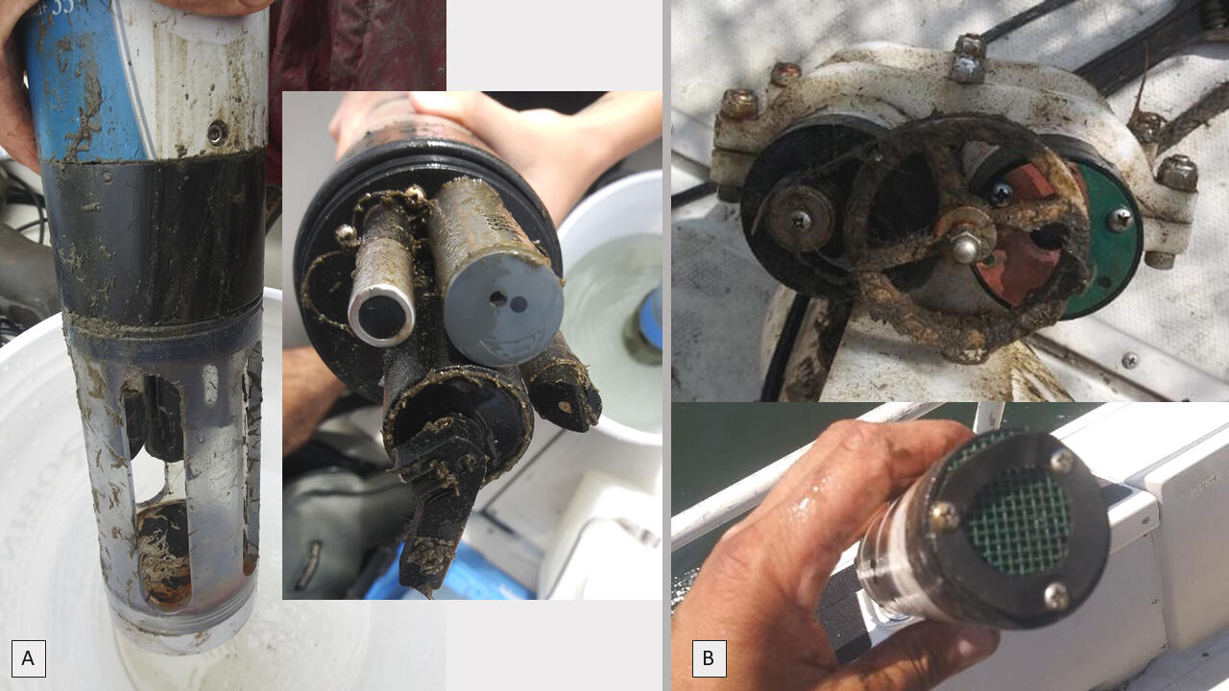

Figure 12 - surface water quality in-situ, [multi-parameter probes, temperature and dissolved oxygen sensors](https://www.usgs.gov/media/images/multi-parameter-probes-temperature-and-dissolved-oxygen-sensors) (USGS)

Other illustrative examples are available in “Annex B: other examples of Surface Water In-situ Quality Use Case.”

## SurfaceWater Ex-Situ Quality Use Case

Surface water ex-situ quality refers to observation data acquired by collecting samples at a site and further analyzing those samples at a laboratory. The range of laboratory measurements is vast and includes measurements of nutrients in various speciation states, trace metals, contaminants, pharmaceuticals, DNA, stable isotopes, etc. In-situ measurements such as temperature and conductivity are often taken on the sample at the site and then the sample is prepared for storage and transport to the laboratory. Sampling occurs following specific collection and sample preparation protocols to ensure the samples are suitable for the target laboratory analyses.

To be able to use ex-situ water quality data, for the measurement observations, users need to know when the measurement occurred (date/time/time zone), sampling procedures including location (latitude, longitude, altitude), measurement units, pre-processing or sample treatment, and sometimes which chemical species are being measured.

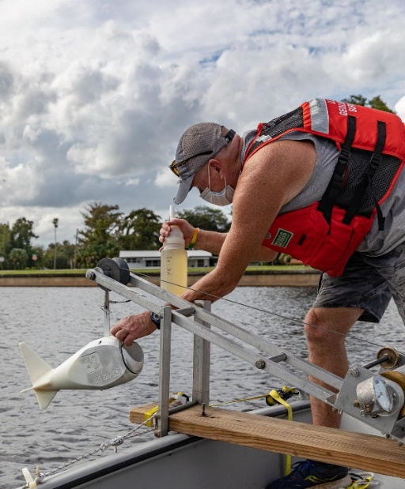

Figure 13 – Example of surface water quality sample for ex-situ analysis

[USGS technician loading a bottle into a DH-95 water-quality sampler](https://www.usgs.gov/media/images/usgs-technician-loading-a-bottle-a-dh-95-water-quality-sampler) (USGS)

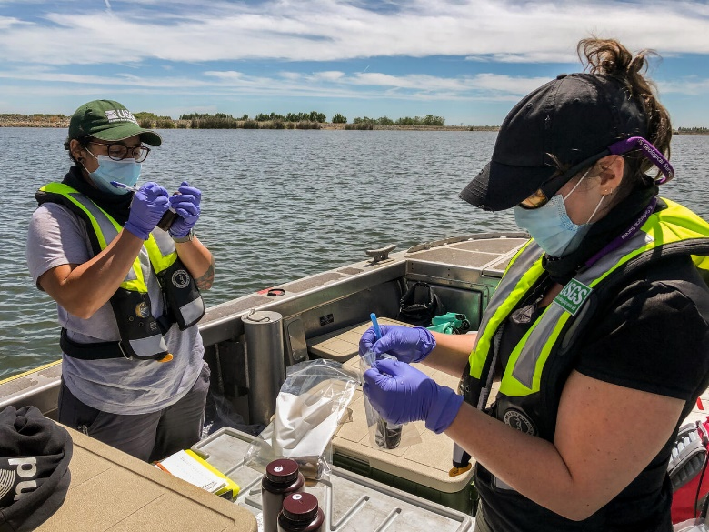

Figure 14 – Example of surface water quality sub-sampling for ex-situ analysis.

[USGS agents preparing samples](https://www.usgs.gov/media/images/jeniffer-soto-perezleft-and-emily-richardson-right-prepare-samples) (USGS)

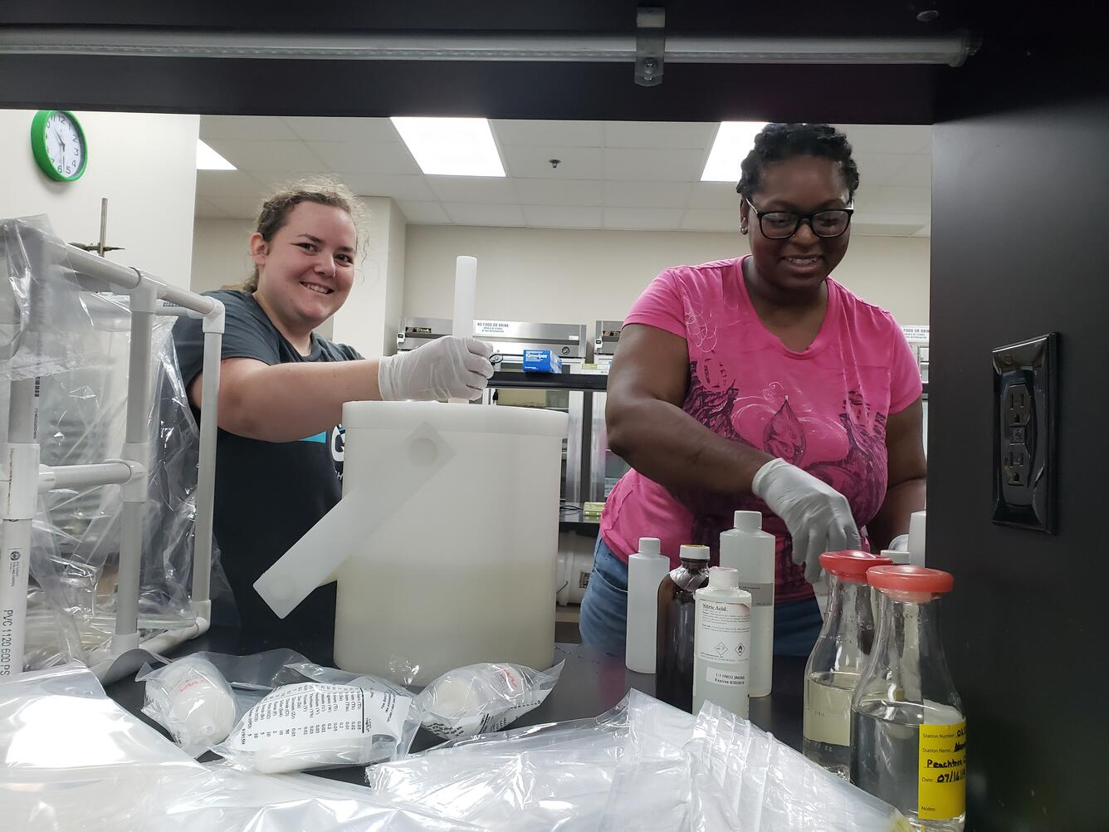

Figure 15 – Example of surface water quality samples for ex-situ lab analysis.

[Studying water quality involves lab work to prepare and analyze water](https://www.usgs.gov/media/images/studying-water-quality-involves-lab-work-prepare-and-analyze-water) (USGS)

Other illustrative examples are available in “Annex C: other examples of Surface Water Ex-situ Quality Use Case”.

## GroundWater In-Situ Quantity Use Case

GroundWater In-situ Quantity refers to observation data acquired on site regarding groundwater levels or groundwater elevation. Measurements are conducted by making a manual measurement using an electric or steel water level tape, or by deploying different measuring instruments, such as transducers or acoustic beam devices, in or on a groundwater well. Groundwater wells may strictly be used for purposes of observation, or may be used for other purposes, such as domestic or irrigation production. Measurements help to determine the depth to water below a measuring point in the well. Groundwater sensors and electronic tapes do require periodic maintenance such as calibration.

To be able to use in-situ groundwater quantity data, data users must know information about the well itself, including location (latitude, longitude, altitude, and datum), the method of measurement, the type of sensor, and if the measurement is being reported relative to land surface or as an elevation relative to a datum. For the measurement observations, users need to know when the measurement occurred (date/time/time zone), sampling procedures, measurement units, and information about the hydrogeologic context (aquifer properties) that the well and measurement represent.

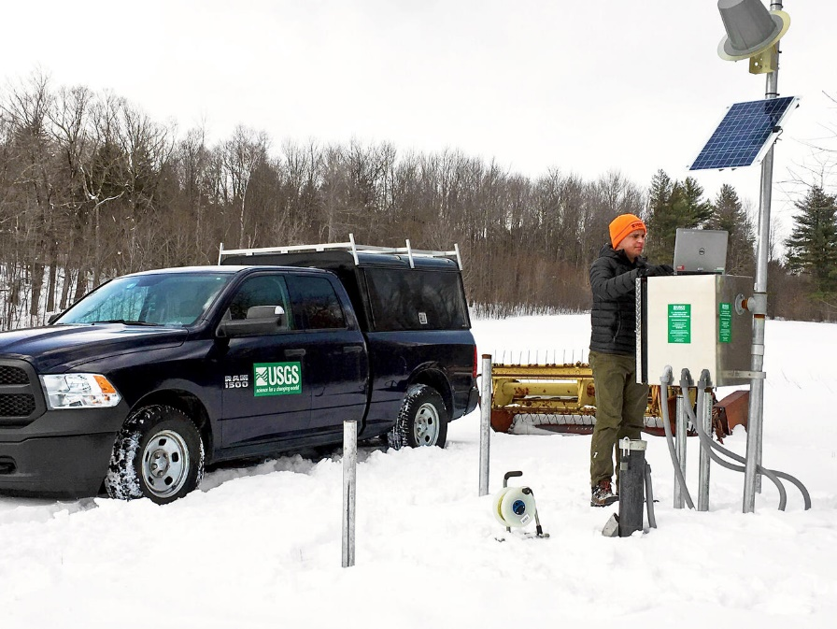

Figure 16 – Example of sensor equipped ground water quantity in-situ monitoring site.

[USGS soil moisture and groundwater well site inspection](https://www.usgs.gov/media/images/usgs-soil-moisture-and-groundwater-well-site-inspection) (USGS)

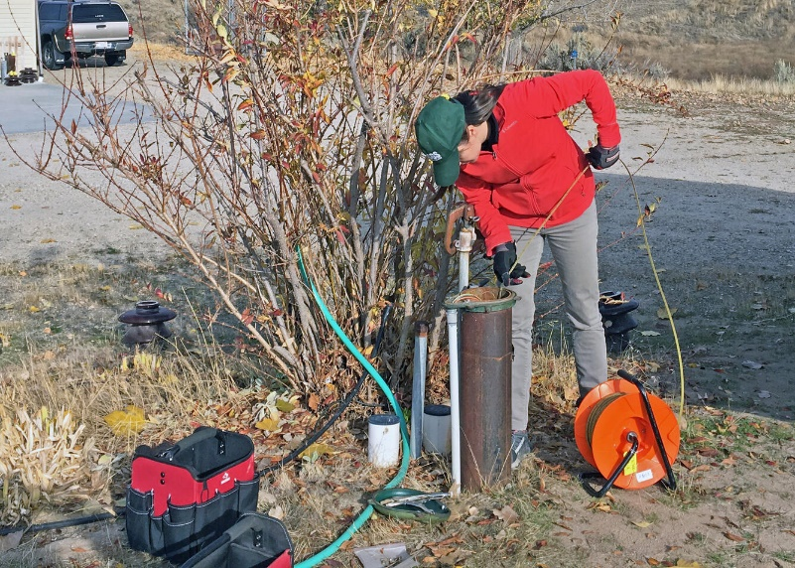

Figure 17 - Example of manual ground water quantity in-situ monitoring.

[USGS hydrologist measuring groundwater level in a well](https://www.usgs.gov/media/images/usgs-hydrologist-measuring-groundwater-level-a-well) (USGS)

Other illustrative examples are available in “Annex D: other examples of Ground Water In-situ Quality Use Case.”

## GroundWater In-Situ Quality Use Case

GroundWater In-situ Quantity refers to observation data acquired on site regarding observable groundwater properties such as temperature, conductivity, pH, dissolved oxygen, nitrogen species (nitrate, nitrite, ammonium) and phosphate. Measurements are conducted by deploying different sensors stationary at various depths. Most existing sensors use optical (colorimetric, fluorescence), electrochemical (potentiometric, amperometric) and electric sensing methods These sensors require periodic maintenance such as calibration and cleaning.

To be able to use in-situ groundwater quality data, users must know various information about the sensor itself, including location (latitude, longitude, altitude), the type of sensor (this relates to measurement accuracy and reliability), and whether there are other measured properties associated with that sensor. For the measurement observations, users need to know when the measurement occurred (date/time/time zone), sampling procedures, measurement units, sometimes which chemical species are being measured, and information about the hydrogeologic context (aquifer properties) that the well and measurement represent.

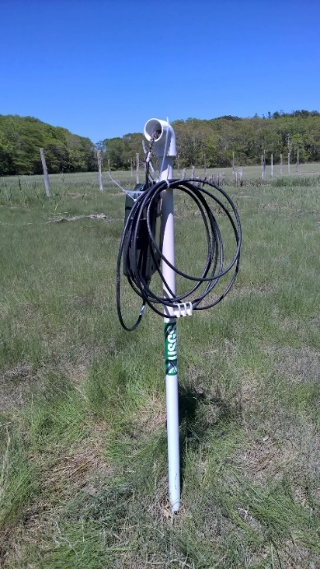

Figure 18 – Example of sensor equipped ground water quality in-situ monitoring site.

[Salt Marsh Well Sensor](https://www.usgs.gov/media/images/salt-marsh-well-sensor) (USGS)

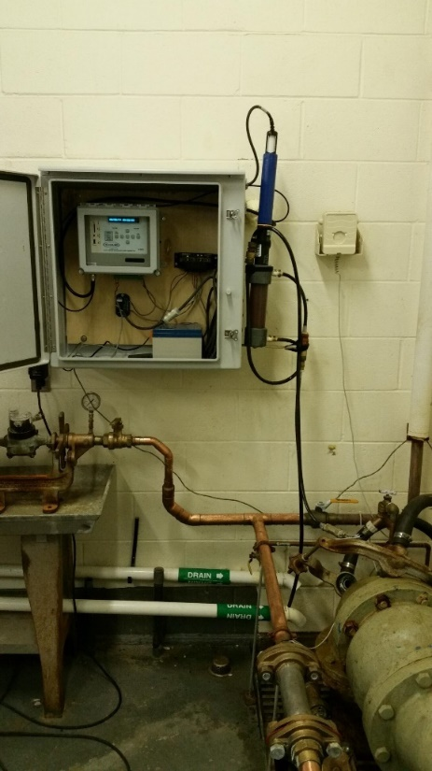

Figure 19 – Example of well pump house instrumentation of for measuring in-situ groundwater quality properties.

[Real-time measurement of variability in groundwater properties](https://www.usgs.gov/media/images/real-time-measurement-variability-groundwater-properties) (USGS)

## GroundWater Ex-Situ Quality Use Case

GroundWater Ex-situ Quality refers to observation data acquired from samples collected at a well. Samples collected at a site are sent to a laboratory for further analysis. The range of laboratory measurements is vast and includes measurements of nutrients in various speciation states, trace metals, contaminants, pharmaceuticals, stable isotopes, etc.

Measurements such as temperature and conductivity are often taken on the sample at the site (after water was pulled from the well, thus ex-situ) and then the sample is prepared for storage and transport to the laboratory. Sampling occurs following specific collection and sample preparation protocols to ensure the samples are suitable for the target laboratory analyses and that the groundwater sample is representative of the aquifer, not a holding tank or other groundwater storage devices.

To be able to use ex-situ groundwater quality data, users must know various information about the monitoring location, such as latitude, longitude, altitude, and the aquifer that the well is representing. For the measurement observations, users need to know when the measurement occurred (date/time/time zone), sampling procedures including location (latitude, longitude, altitude, vertical component of the sample), measurement units, laboratory methodology, information about sample handling (such as filtering), which chemical species is being measured and its speciation, and sample fraction.

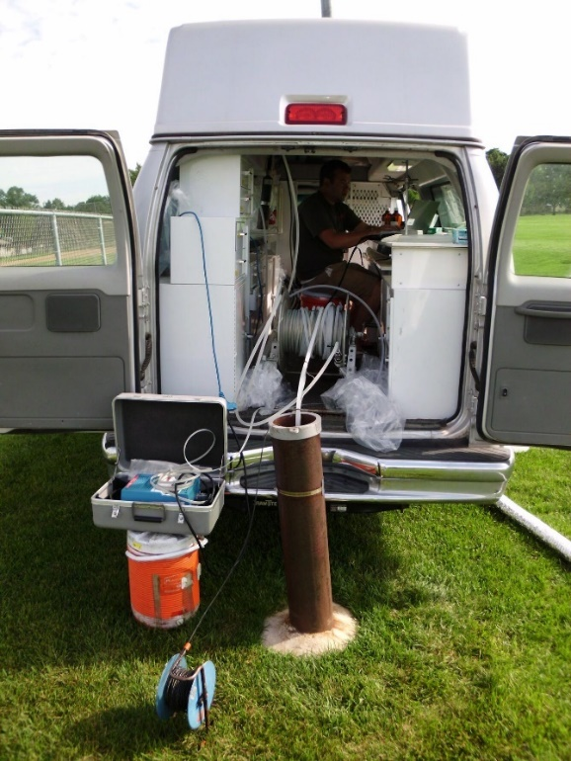

Figure 20 – Example of surface water quality sample for ex-situ analysis.

[USGS Scientist Sampling Groundwater for Contaminants](https://www.usgs.gov/media/images/usgs-scientist-sampling-groundwater-contaminants) (USGS)

Other illustrative examples are available in “Annex E: other examples of Ground Water Ex-situ Quality Use Case.”

# Object Diagrams

## Methodology

Domain needs stemming from the Use Cases have been evaluated in front of OGC Semantic baseline using the following standards:

* OGC/ISO ISO 19156:2023: Observations, Measurements, and Samples (OGC 20-082r4, a.k.a OMS);
* OGC® WaterML 2: Part 3 – Surface Hydrology Features (HY_Features) – Conceptual Model 1.0 (OGC 14-111r6); and
* OGC WaterML 2: Part 4 – GroundWaterML 2 (GWML2) 2.2 (OGC 16-032r2).

After several discussion rounds, it became clear that the vast majority of the domain needs were already covered by the identified standards.

Building on this, the major challenge was not to define international agreed upon semantics but rather guide the community through the already available one.

In a step-by-step approach, the first exercise was to graphically represent the various situations covered by the UseCases in simple “boxes and arrows” diagrams to be sure all IE members had the same vision.

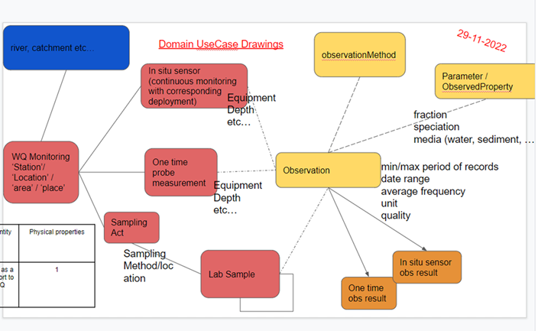

Figure 21 – First Use case drawings

From this point, it became obvious that an OMS crash course was necessary for the WQ IE members. Training material on both topics is definitely a must-have to help embark communities into those practices. Luckily having co-chairs of both standards is highly helpful in that case.

The group was then able to move from the above diagrams to concrete UML object diagrams.

They are detailed below in the following sections.

After thorough “object diagramming” sessions two clear data patterns appear that enable to group the diagrams as follows.

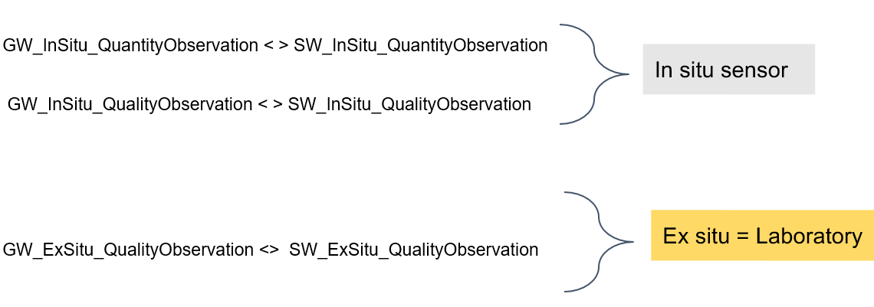

Figure 22 - Use case grouping into two main data patterns

*Note: In the previous figure, ‘GW’ stands for ‘GroundWater’ and ‘SW’ for Surface Water.*

Complementary to the “In Situ” VS “Ex situ” grouping another sub-grouping appears with regards data patterns regardless of the surface/ground water type. Sub-grouping that is the following:

* In Situ Quantity
* In Situ Quality
* Ex Situ Quality

All the object diagrams are available on the OGC Sparx Cloud:

<https://umltool.ogc.org/index.php?m=7&o=3F16B0F9-C7E2-4bed-AA4A-5C9FED57C1F6>

## Reading Object Diagrams

The objects appearing in the following object diagrams are instances of classes defined in the mentioned standards. Their properties values are filled from concrete examples available in the national systems used in the described use cases.

Each box displayed in an object diagram represents a concrete instance of a specific class. In the top compartment one find the name of the individual object followed by a ‘:’ character followed by the class name. In the example below, the object named **FlowObservation** of type*Observation* is displayed as “FlowObservation:Observation”. In the second and third compartment one find attributes from the classes the objects are defined on together with their values.

Below is a simple object diagram example in which is shown a *Host* linked to an *Observation*. In the *Host* object named **Station Orléans [Pont Royal] (Loire)**, one sees the following attributes with their values:

* link: <https://www.hydro.eaufrance.fr/stationhydro/K435001010/fiche>;
* depthReferencePoint: a complex geometry datatype that cannot be displayed; and
* elevation: of type measureType with value ‘10’.

In addition, one can see that this *Host* is linked to an *Observation* named **FlowObservation** via the *relatedObservation* role on the association.

Looking at **FlowObservation**, one cansee the following attributes with their values:

* result: 114,6 m^3/s
* phenomenonTime: 20230307T1140
* validTime: 20230307T1140
* resultTime: [20230307T1140- ]

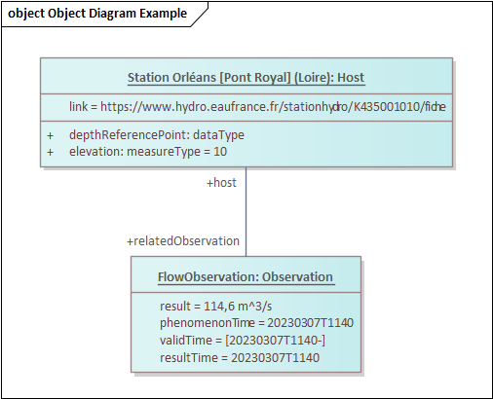

Figure 23 – Object diagram example

## In situ data patterns

### In situ surface water quantity

The following object diagrams describe the river gage/height monitoring setup at a station in Orléans (France) for a single observation.

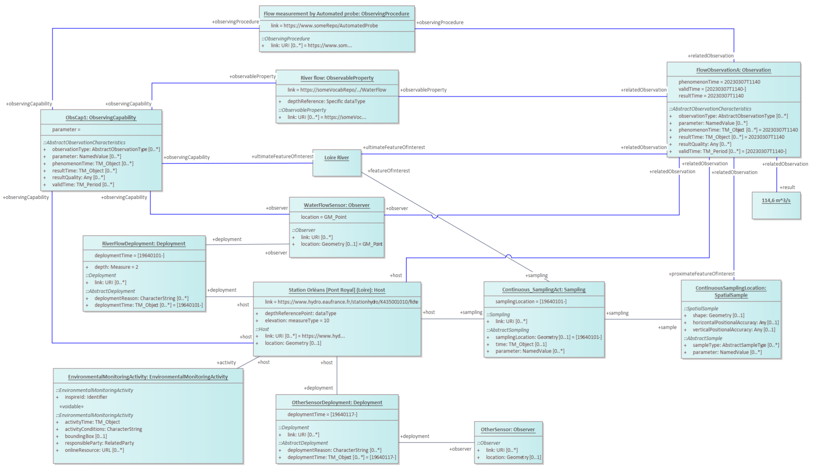

Figure 24 – In situ surface water quantity single observation

The main information elements from a hydro domain point of view can be overlaid as follows.

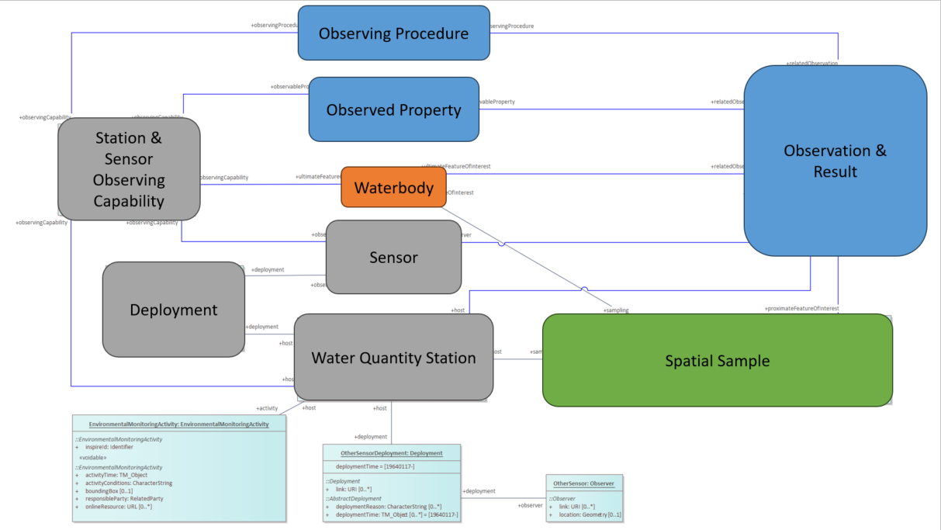

Figure 25 – In situ surface water quantity single observation (simplified)

Observations can be then grouped into collections usually called TimeSeries.

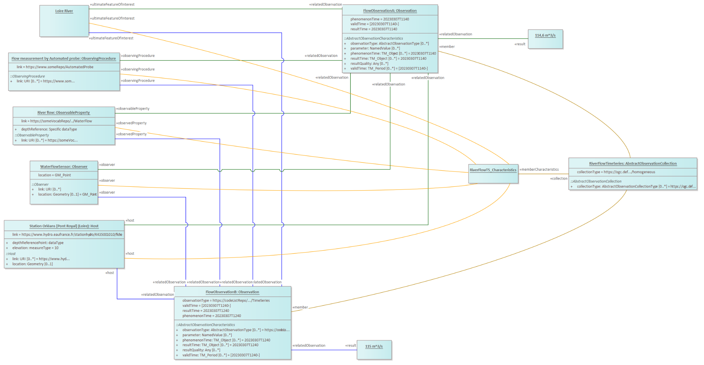

Figure 26 – In situ surface water quantity timeseries observation

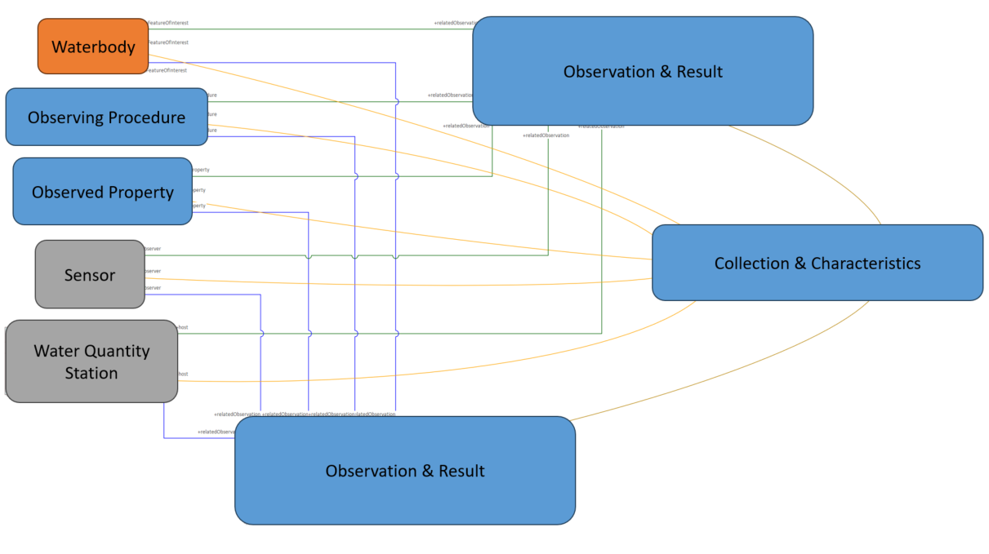

Figure 27 – In situ surface water quantity timeseries observation (simplified)

### In situ ground water quantity

The following object diagrams describe the groundwater depth monitoring setup at an aquifer (Complément de l'entité NV2: Formations plio-quaternaires de la Dombes) for a single observation.

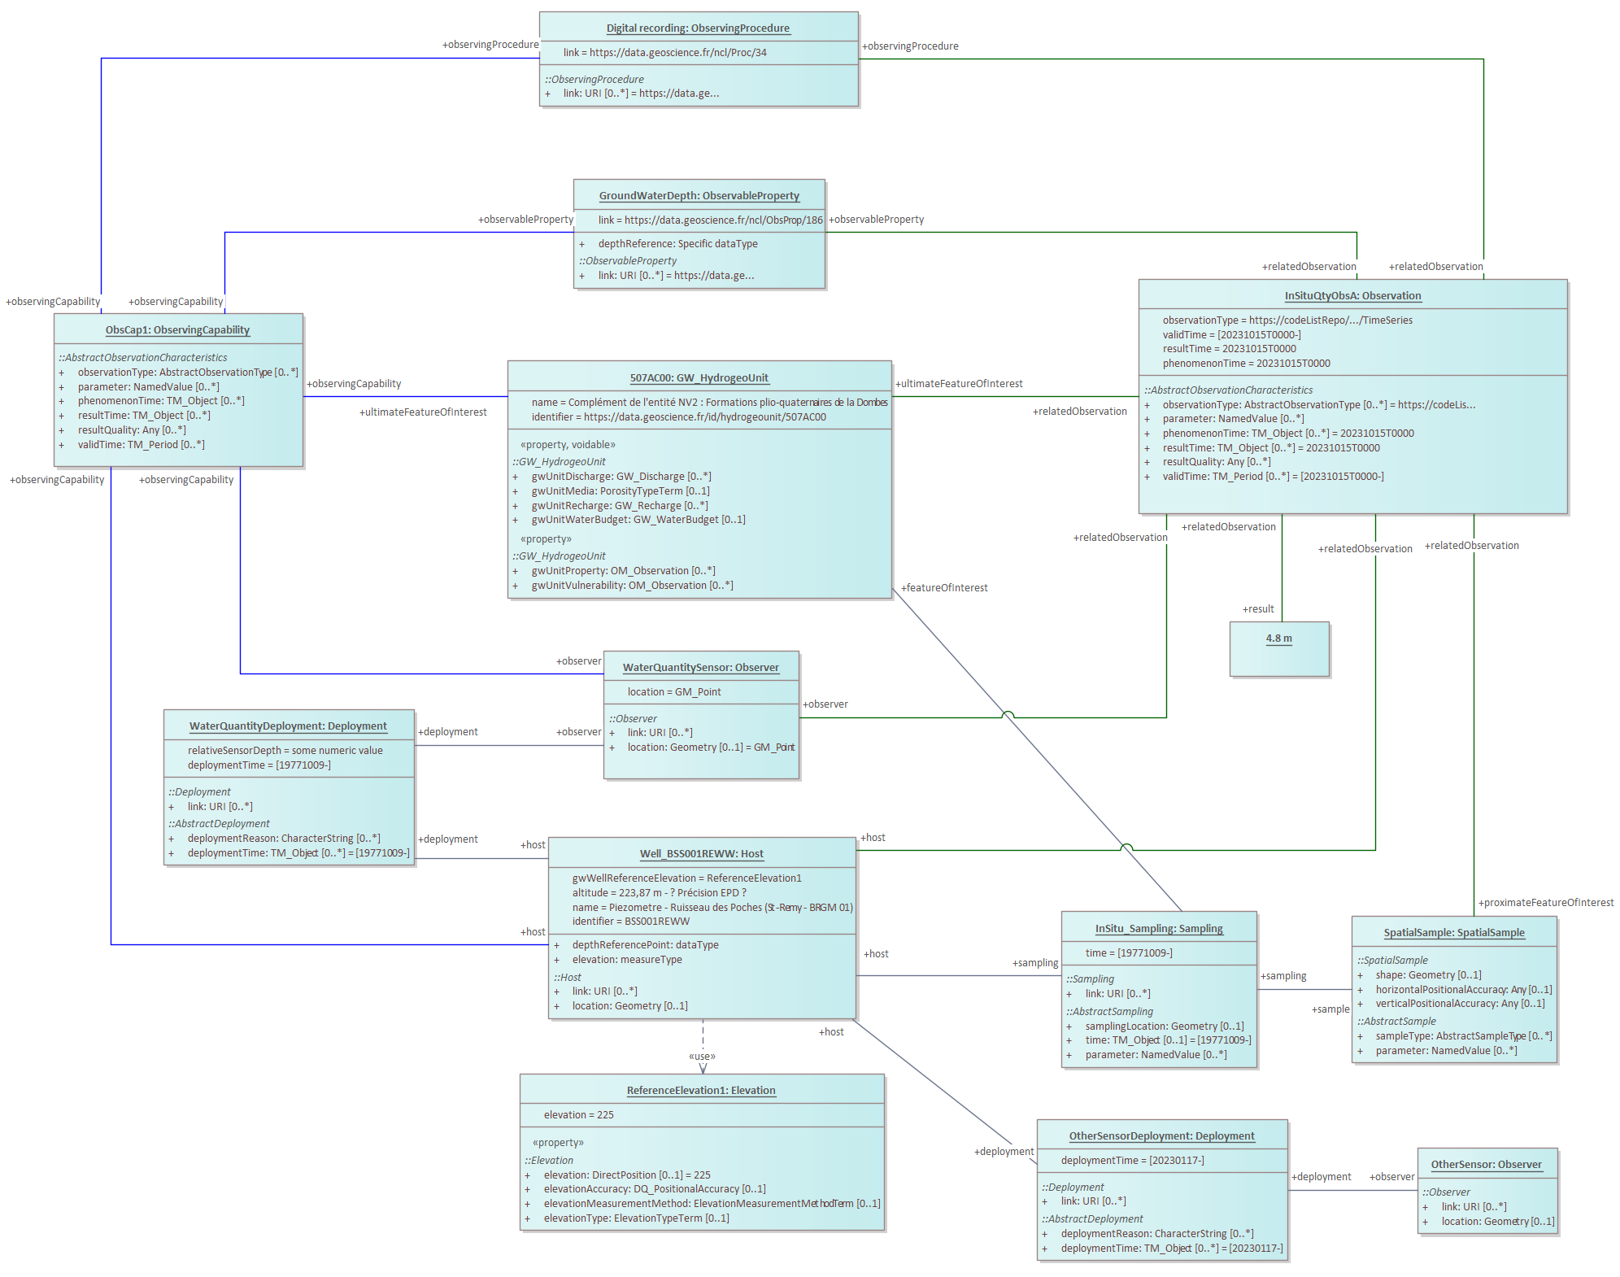

Figure 28 – In situ ground water quantity single observation

Observations can be then grouped into collections usually called TimeSeries:

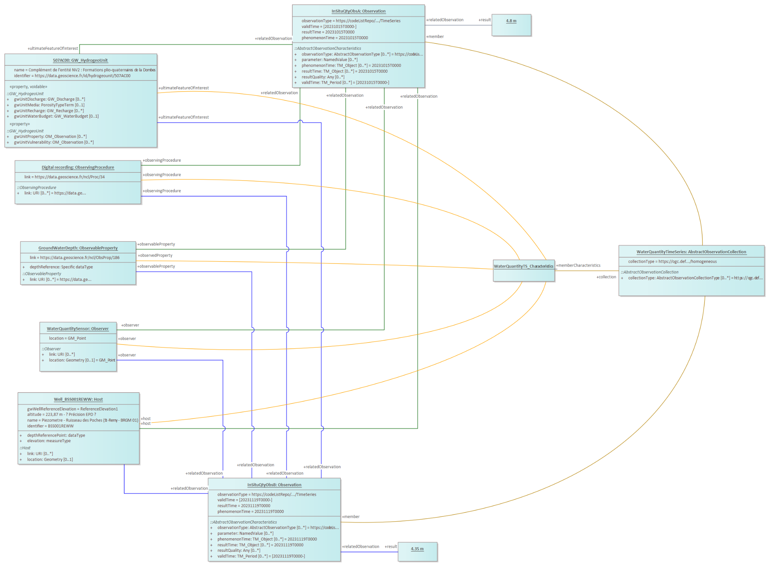

Figure 29 – In situ ground water quantity timeseries observation

### In situ surface water quality

The following object diagrams describe the water temperature monitoring setup at a surface water station for a single observation. In addition, it illustrates how a sampling can be used to more closely indicate the actual object on which the observation is performed, as well as providing information under which activity this monitoring is being performed.

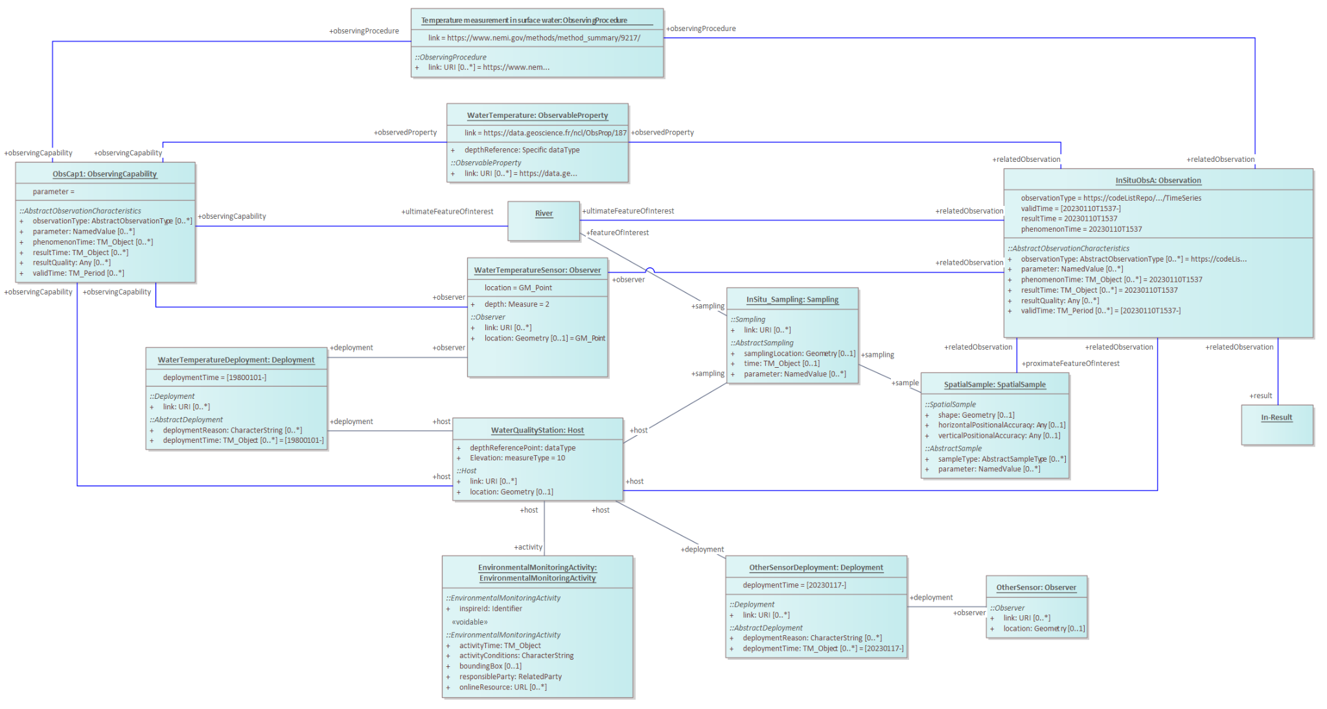

Figure 30 – In situ surface water quality single observation

Observations can be then grouped into collections usually called TimeSeries:

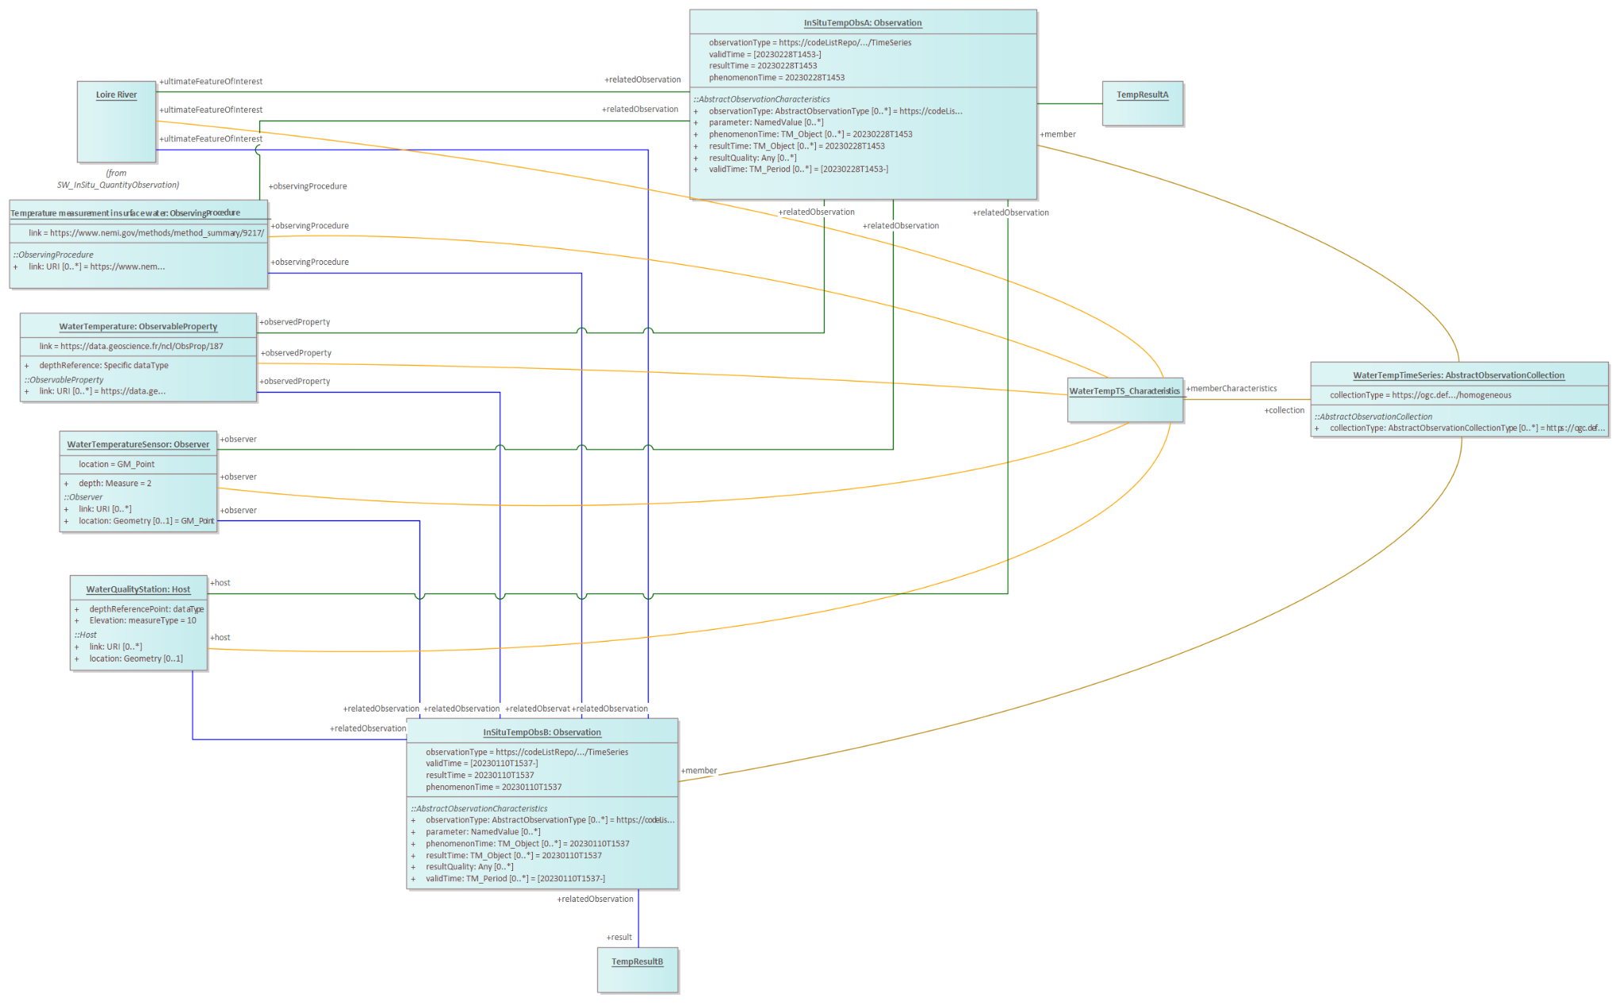

Figure 31 – In situ surface water quality timeseries observation

### In situ ground water quality

The following object diagrams describe the water temperature monitoring setup at a ground water station for a single observation. In addition, it illustrates how a sampling can be used to more closely indicate the actual object on which the observation is performed.

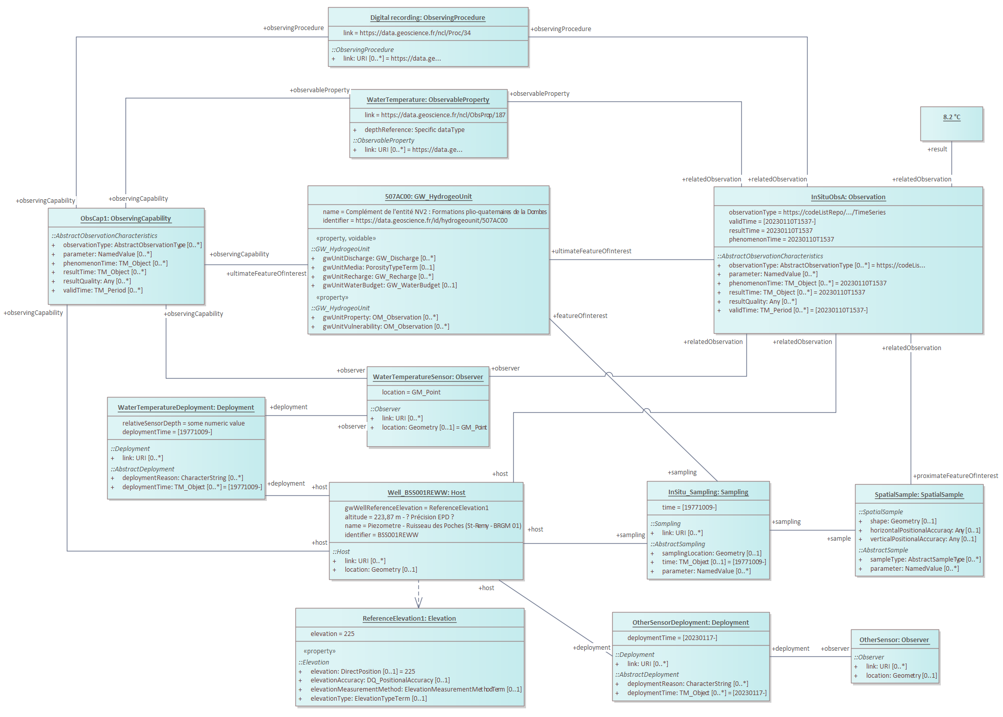

Figure 32 – In situ ground water quality single observation

Observations can be then grouped into collections usually called TimeSeries:

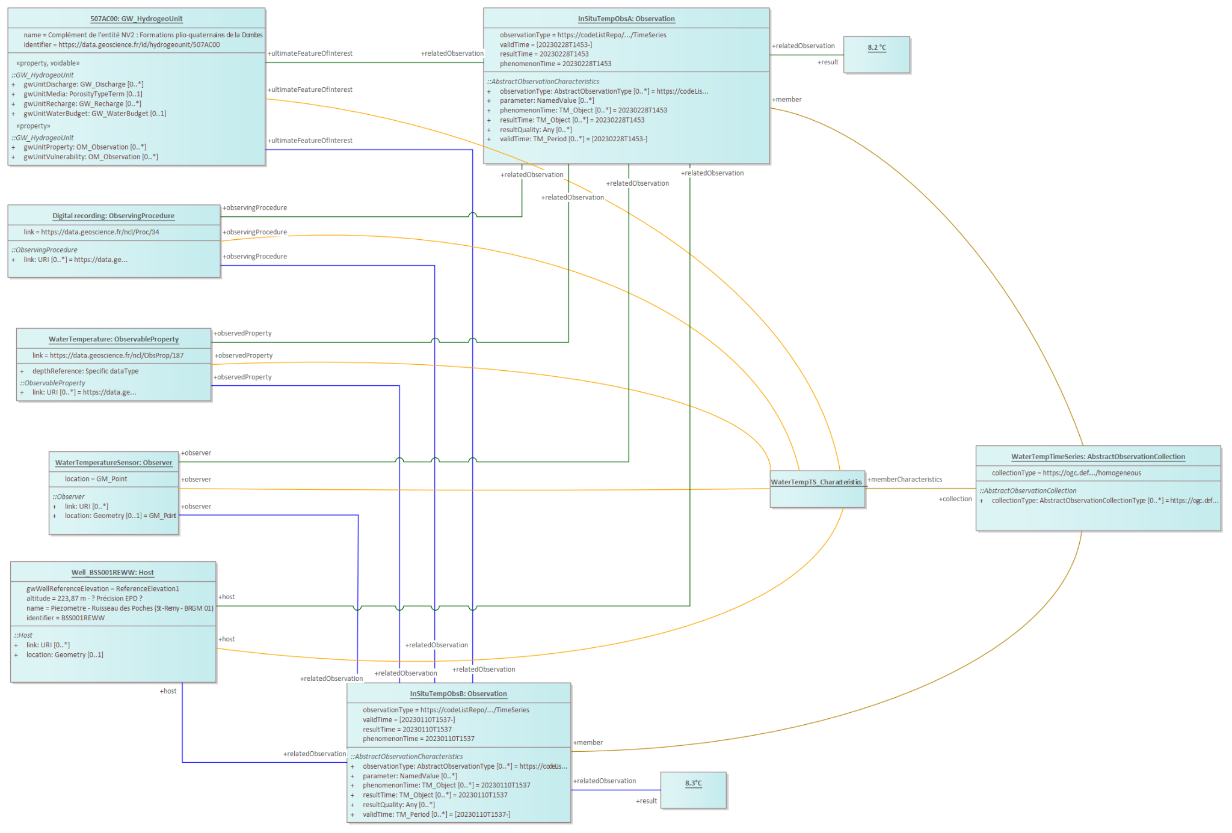

Figure 33 – In situ ground water quality timeseries observation

## Ex situ data patterns

### 6.4.1 Ex situ surface water quality

The following diagrams describe the setup at a monitoring station on the Loire river measuring the ObservableProperties “dissolved oxygen” and “pH”. As this is an *ex situ* example, the Observation is taken on a Sample that is analyzed in a lab. In the first diagram, only the MonitoringCapabilities are provided, showing what potential Observations could be generated at this station.

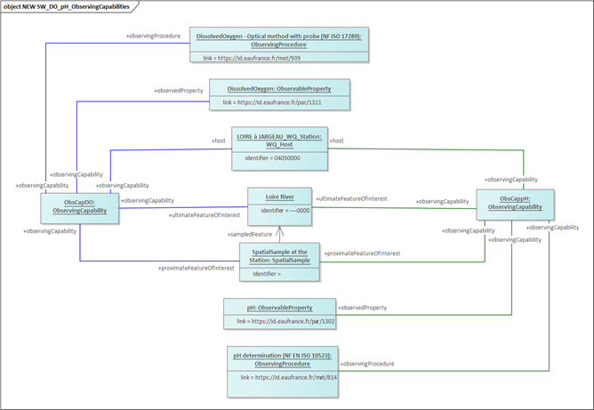

Figure 34 – Ex situ surface water quality single observation

In the following diagram, a “pH” Observation and a “dissolved oxygen” Observations are illustrated, both taken from a sample from a station on the Loire River.

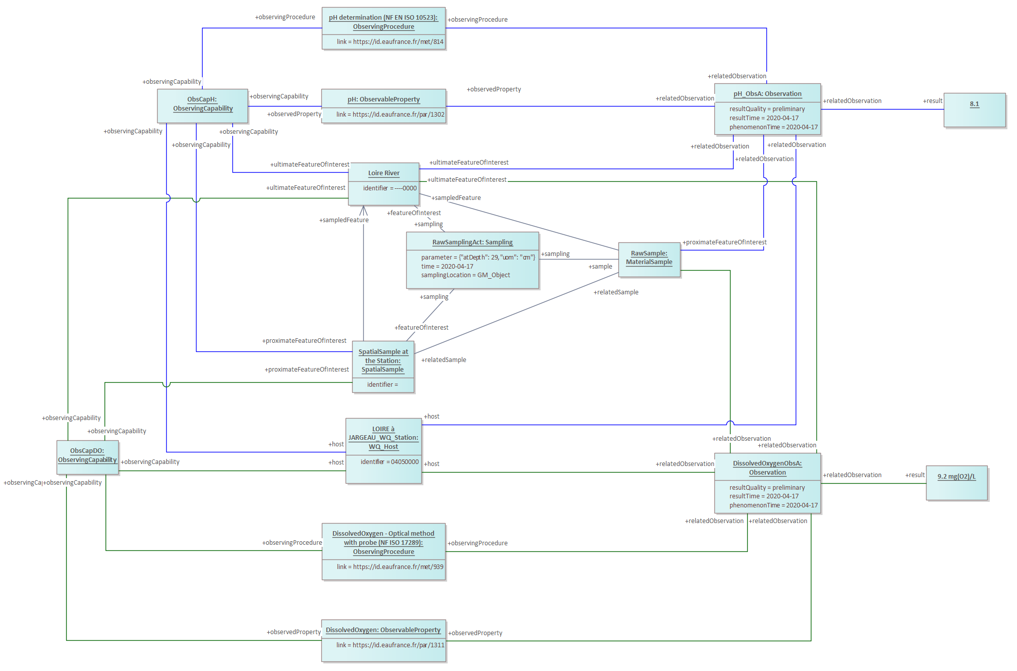

Figure 35 – Ex situ surface water quality sampling context

In the following diagram, two dissolved oxygen Observations are being grouped to a collection, usually called TimeSeries:

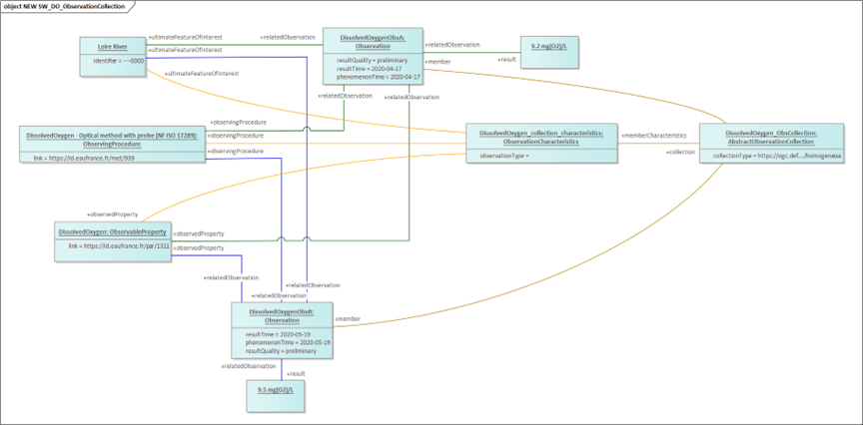

Figure 36 – Ex situ surface water quality timeseries Dissolved Oxygen observation

In the following diagram, two pH Observations are being grouped to a collection, usually called TimeSeries:

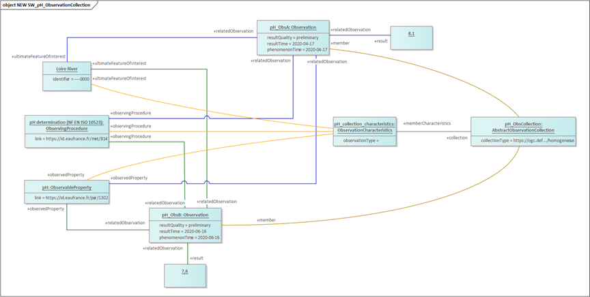

Figure 37 – Ex situ surface water quality timeseries pH observation

### 6.4.2 Ex situ ground water quality

The following diagrams describe the setup on an aquifer being accessed by a well. The ObservableProperties in this example are arsenic and nitrate. The example shows the ObservingCapabilities of the station, the creation of a Sample and an arsenic and nitrate Observation on this Sample.

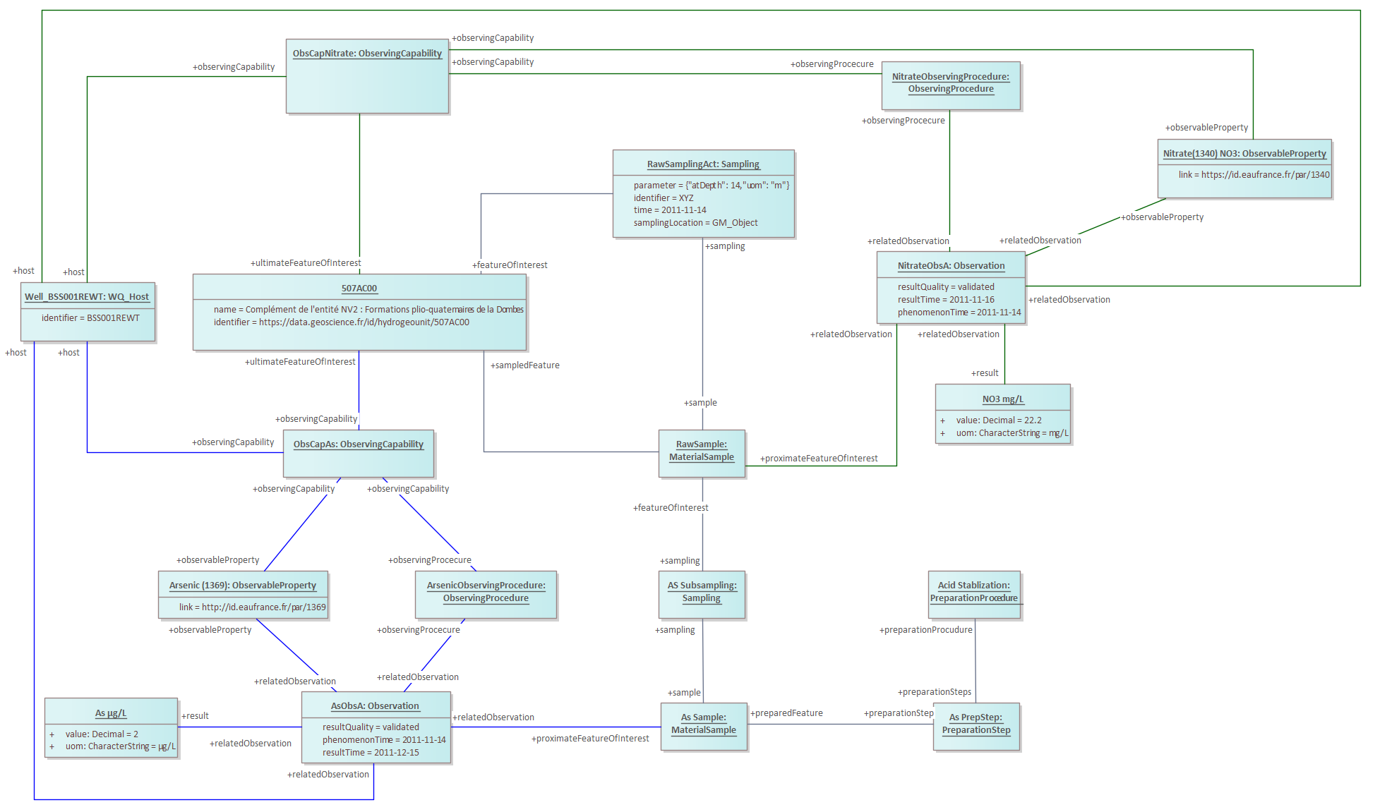

Figure 38 – Ex situ ground water quality sampling act and associated observation

# Logical Model

## Methodology

Once the individual Use Cases had been broken down into Object diagrams, the requirements were reflected against the agreed data models (OMS as well as WaterML 2 Parts 3 Surface Hydrology Features (HY_Features) and OGC WaterML 2: Part 4 – GroundWaterML 2), and gaps identified. While just about all requirements were covered by the existing data models, this task led to the insight that the following additions were required to the OMS model to support the requirements of the WQ IE:

* Sampling and Deployment: addition of depth information to both classes; and
* Sampling and Host: addition of an association between these two classes.

## Additional Classes

In order to ease modeling, the WQ IE Logical Model was based on the recently proposed [OMS Logical Model](https://umltool.ogc.org/index.php?m=7&o=80B3D139-545F-4172-88B4-76B62A1754D2). This model provides all classes and associations from all three tiers of the OMS Standard, whereby all associations are available at this level, and not obfuscated in the derivation hierarchy. The ‘LA_’ prefix on all classes indicate they are from the Logical Abstract model.

The additional requirements listed above required the creation of specialized types for Sampling, Host and Deployment. The following types were created.

* WQ_Sampling: derived from OMS *Sampling* with the addition of the following attributes:
  + atDepth (Integer): Depth at which the sampling act took place;
  + depthUoM: Unit of measurement in which *atDepth* is represented; and
  + host: a link to a *Host* at which this sampling act was performed
* WQ_Deployment: derived from OMS *Deployment* with the addition of the following attributes:
  + atDepth (Integer): Depth at which the sensor (*Observer*) has been deployed on the *Host*; and
  + depthUoM: Unit of measurement in which *atDepth* is represented.
* WQ_Host: derived from OMS *Host* with the addition of the following attributes:
  + sampling: a link to a sampling act (*Sampling*) performed at this *Host.*

The definition of WQ_Sampling, WQ_Deployment and WQ_Host can also be seen in the diagram below (<https://umltool.ogc.org/index.php?m=7&o=CEE30349-7A67-44ae-BD9A-102A94963E65>).

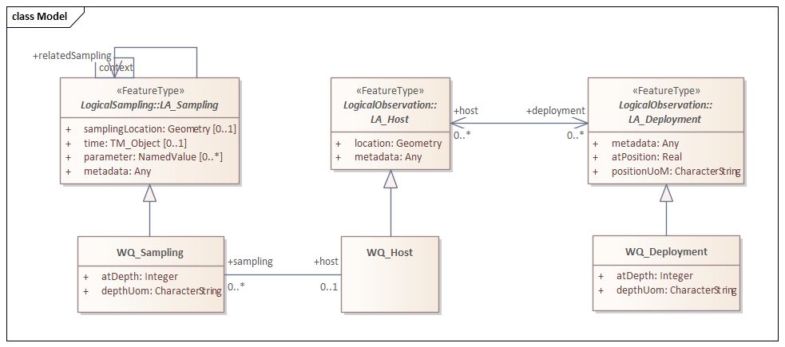

Figure 39 – Water Quality IE Logical Model

# Physical Model

## Methodology

The “OGC SensorThings API Part 1: Sensing Version 1.1” (OGC 18-088, a.k.a. STA) already has an OGC/ISO 19156:2011: Observations & Measurements (OGC 10-004r3, a.k.a. O&M) compatible physical model, and it has the capabilities to manage and query relations between entities. In addition, STA is flexible in allowing for the inclusion of additional attributes on all classes. This made the STA data model a good candidate to base the physical WQ-IE data model on.

As mentioned in section 7.1 “Methodology,” the object diagrams that guided this work were based on the updated OMS standard (OGC/ISO ISO 19156:2023) as well as WaterML 2.0 Parts 3 (Surface Hydrology Features (HY_Features)) and 4 (GroundWaterML 2). These standards contain classes that are not supported by STA 1.1. This led to a rapid prototyping exercise where how to integrate these additional concepts into STA was investigated while maintaining alignment with the modelling paradigms ensuing from STA. As STA has added the concept of extension modules, the additional requirements from the WQ IE Use Cases and Object Diagrams were structured into the following three extensions to the core STA data model (note direct links to OGC UML Tool are provided as hyperlinks for each category).

* [OMS](https://umltool.ogc.org/index.php?m=7&o=B3082E93-FF7F-44d1-8072-3E03EA9CDBAC): In order to support Use Case requirements in line with the OMS update, the *FeatureOfInterest* association from *Observation* to *FeatureOfInterest* has been complemented with the addition of an *UltimateFeatureOfInterest* association from *Datastream* to *FeatureOfInterest*, the *FeatureOfInterest* semantics are now aligned with *proximateFeatureOfInterest* from OMS. In addition, the *FeatureOfInterest* class has been renamed to *Feature*. In addition, the following two classes have been added from OMS:
  + **Observing Procedure**: the description of steps performed in order to determine the value of an *observableProperty* by an *Observer*; and
  + **Deployment**: information on the assignment of an *Observer* to a *Host*.
* [Sampling](https://umltool.ogc.org/index.php?m=7&o=65802158-1868-4306-803B-F0B57C2EF3F5): Within the Use Cases, there was a requirement to provide details on the sampling process. STA 1.1 did not support sampling in any form. Thus, the classes from OMS were added to the STA data model:
  + **Sampling**: an act applying a *SamplingProcedure* to create or transform one or more *Sample*(s);
  + **Sampler**: a device or entity (including humans) that is used by, or implements, a *SamplingProcedure* to create or transform one or more *Sample*(s);
  + **SamplingProcedure**: the description of steps performed by a *Sampler* in order to extract a *Sample* from its *sampledFeature* in the frame of a *Sampling*;
  + **PreparationStep**: an individual step pertaining to a *PreparationProcedure*; and
  + **PreparationProcedure**: the description of preparation steps performed on a *Sample*.
* [Relations](https://umltool.ogc.org/index.php?m=7&o=109BD5C8-2A58-4d4d-BD59-761B619B471A): In some cases, it is useful to be able to indicate that a Feature is related to a different Feature, providing information on how these two Features relate. The same holds true for Things, Datastreams and Observations. Thus, a Relations extension was created enabling this type of additional links.

The STA 2.0 revision process started during the second half of the WQ IE. All of these extensions have then been integrated into the STA 2.0 update with only minor modifications (e.g. the atDepth attribute of the WQ IE Deployment was modified to position in STA 2.0 to make this concept more domain neutral). In addition, all classes from the STA based WQ IE data model have been [mapped](https://umltool.ogc.org/index.php?m=7&o=F850AB75-5B17-4a7a-8550-2BDB5347C159) against the relevant OMS classes to confirm semantic cohesion.

## SensorThings / OMS mapping

The following table set up by the OGC SensorThings Standard Working Group introduces the mapping between SensorThigns and OMS concepts[2].

|  |  |
| --- | --- |
| **SensorThings API Entities** | **OMS Concepts** |
| Thing | Host |
| Datastream | ObservationCollection |
| Sensor | Observer |
| Observation | Observation |
| ObservedProperty | Observed Property |
| Feature | Feature |
| Deployment (OM Extension) | Deployment |
| ObservingProcedure (OM Extension) | Observing Procedure |
| Sample (Sampling Extension) | Sample |
| Sampling (Sampling Extension) | Sampling |
| SamplingProcedure (Sampling Extension) | Sampling Procedure |
| PreparationProcedure (Sampling Extension) | Preparation Procedure |
| PreparationStep (Sampling Extension) | Preparation Step |

The SensorThings model with the Water Quality IE additions (STA 2.0 WQ IE draft) is available on the OGC UML (<https://umltool.ogc.org/index.php?m=7&o=0E6BAD11-FDDE-46fa-B058-B403876971C8>).

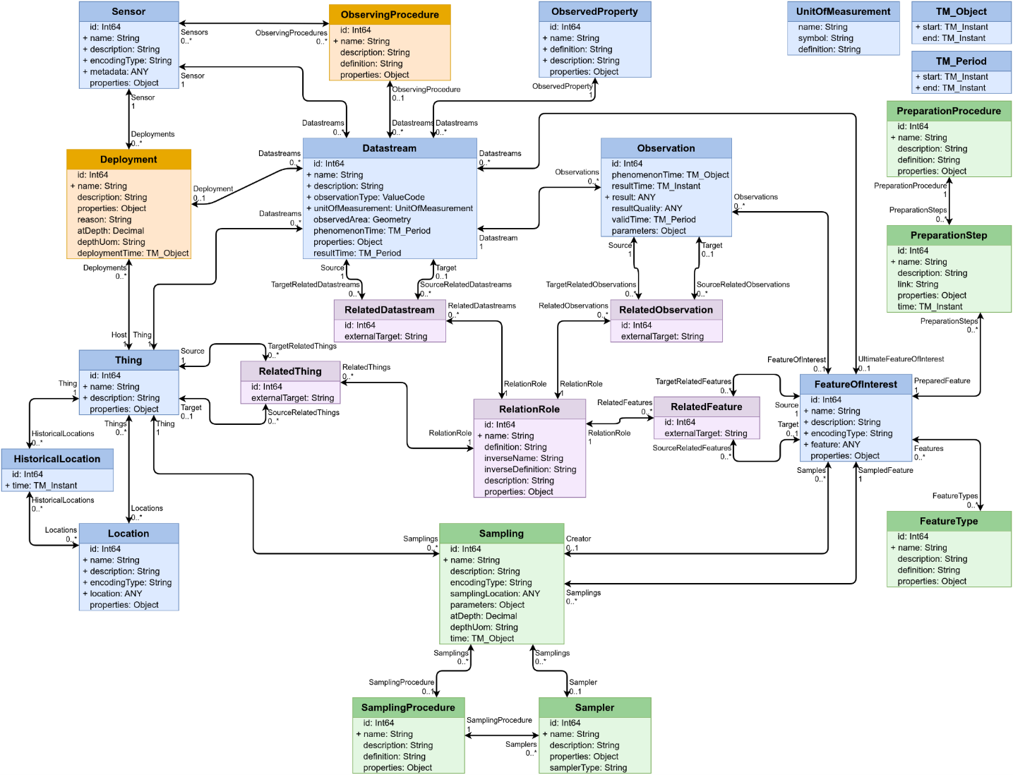

Figure 40 – STA 2.0 WQ IE draft

## SensorThings API deployment recommendations

Alongside the deployment documentation prepared to help the IE members deploy solutions (available in Annex K: Water Quality IE Deployment Documentation), several additional recommendations were identified.

* + 1. Observable Property Codelists

The reuse of observable property codelists where possible is strongly recommended, as otherwise it is often difficult to determine what property was actually meant, especially in a multilingual context. Where possible these individual observable property codelists should be underpinned by stable URIs, allowing for a direct reference to each individual concept provided by the codelist. Where such a URI (URL) is available to a controlled vocabulary describing the observable property, this should be provided in the “Definition” attribute of the corresponding ObservedProperty object.

* In the United States of America, the USGS historically used a 5-digit ‘pcode’ to uniquely identify measured properties. Given that it had too much additional metadata attached, USGS now delivers measured properties as Observable Properties in the WQX version 3.0 format; [references are available to crosswalk](https://waterdata.usgs.gov/code-dictionary/) these different nomenclatures. The EPA maintains a list of [controlled vocabularies](https://www.epa.gov/waterdata/storage-and-retrieval-and-water-quality-exchange-domain-services-and-downloads#domain) available and [recommendations](https://www.epa.gov/waterdata/water-quality-data) for data exchange.
* In France, the code list provided by the French water information system do provide a basis for work but don’t respect FAIR principles for vocabularies. For this reason the OneWater research project along with the French Research Infrastructure Theia/OZCAR are providing better semantic web oriented access to those types of resources.
* The European Environment Agency (EEA), uses its data dictionary vocabulary server to provide all sorts of codelists required for reporting under different environmental domains. As water quality data fall under the the Water Information System for Europe (WISE), all water relevant Observable Properties collected by the EEA are available from:  
  <https://dd.eionet.europa.eu/vocabulary/wise/ObservedProperty/view>
* In Italy, at ISPRA, the chemical substances are described into a dedicated ontology: <https://semscout.istc.cnr.it/whow/lodview/controlled-vocabulary/chemical-substances>.
  + 1. Reference to domain features

The term ‘domain feature’ corresponds to the features being monitored and for which observations are acquired (ex: a River, a Catchment, an Aquifer, etc.). Those have to be exposed as SensorThings API:FeatureOfInterest

It is recommended to put the references (URIs / URLs) to external systems providing a more thorough description in the FeatureOfInterest/description property. Such external system could be an OGC Web Feature Service or OGC API – Features.

The typing of those FeatureOfInterest is to be done via the FeatureType using well established and community agreed types. As such, the FeatureType/definition should point to reference vocabularies (ex : <https://www.opengis.net/def/schema/hy_features/hyf/HY_River> for a River)

# Testing

Water Quality IE recommendations have been implemented and tested in various organizations and also across various tools.

Several of those testing descriptions are complemented by mapping in annexes.

## North America

The proposed approach was tested using water quality data from both the United States and Canada, demonstrating cross-border interoperability in water quality data exchange. The implementation leveraged existing water quality data standards and repositories from both countries, mapping them to the SensorThings API with Water Quality IE extensions.

### United States

In the United States, the testing focused on the Water Quality Portal (WQP) (<https://waterqualitydata.us> ), which serves as the nation's primary aggregation of water quality sample data. The WQP integrates data from multiple federal, state, tribal, and local agencies using the Water Quality Exchange (WQX) standard as its underlying data model (<https://exchangenetwork.net/data-exchange/wqx/>). This implementation involved mapping WQP's Stations and Physical/Chemical results data profiles to the SensorThings API with Water Quality IE extensions.

The mapping process (detailed in “Annex F: WQX mapping to WQ IE”), established clear correspondences between WQX elements and SensorThings API entities. Based on the mapping document, key relationships included the following.

* **Monitoring Locations to Things and Locations**: WQP monitoring locations were mapped to STA Thing entities and properties, with Location metadata (coordinates, elevation) maintained as Location properties.
* **Characteristics to ObservedProperties**: WQX characteristics were mapped to STA ObservedProperty entities, preserving parameter codes and definitions.
* **Results to Observations**: WQX sampling activities and analytical results were mapped to STA Observation entities.
* **Activity and Sample Collection to Sampling and Sample entities**: WQX activity and sample collection metadata was mapped to STA Sampling actions and Sample entities.

Some mappings were relatively straightforward, such as monitoring location metadata and observational results. However, several aspects presented challenges.

1. **Datastreams:** WQX rests on a discrete-sample oriented data model and thus does not model the STA Datastream concept directly. Instead, Datastreams were constructed from distinct combinations of Monitoring Locations, Characteristics, and UnitCodes, which together satisfy the grouping of water quality sample observations implied by a Datastream. Since analytical methods (which would in principle be modeled in STA as Sensors or ObservingProcedures) were relatively sparsely populated in WQP data, Datastreams were constructed without distinguishing between analytical methods for the purposes of the experiment.
2. **Sample Preparation Procedures**: The mapping of WQX sample preparation methods to STA PreparationProcedure entities required careful handling of the preparation step sequences and method references
3. **Activity-Result-Sample Relationships**: The WQX model has complex relationships between activities, results, and samples that needed to be carefully translated to maintain data integrity in the STA model
4. **Quality Assurance Metadata**: WQX contains detailed quality assurance information that needed to be preserved appropriately in the STA model's properties structures
5. **Ultimate Feature of Interest References**: The mapping leveraged the OMS distinction between proximate and ultimate features of interest. Linking Datastreams to their ultimate Features of Interest (watersheds, waterbodies) was challenging due to inconsistent referencing of these features in the source data. While monitoring locations (proximate Features of Interest) were directly represented as FeaturesOfInterest for observations, the watershed, waterbody, or aquifer (ultimate features) were properly linked to Datastreams when that information was available in WQX or the U.S. Geological Survey Network Linked Data Index (NLDI) (<https://waterdata.usgs.gov/blog/nldi-intro/>), which includes persistent identifiers for these kinds of features as furnished by the [Geoconnex.us](http://geoconnex.us) system.

A custom data ingestion pipeline (<https://github.com/cgs-earth/wis2box/tree/wqx/wis2box>) was developed to programmatically download data from the WQP web services, transform it according to the established mapping, and load it into a SensorThings API endpoint with Water Quality IE extensions (<https://wqp.wqie.internetofwater.app/FROST-Server/v1.1>). This pipeline processed metadata about monitoring locations, observed properties, and results data, creating the appropriate STA entities and relationships.

For testing purposes, two geographic regions were specifically targeted.

1. **Colorado Region**: This region was selected to demonstrate interoperability with existing USGS streamgages and New Mexico Bureau of Geology groundwater wells, both of which had their own SensorThings API 1.1 endpoints. This testing showed how water quantity and quality data from different agencies could be integrated through standardized APIs.
2. **Wayne County, Michigan Region**: This area was chosen to demonstrate cross-border interoperability with Canadian data sources, focusing on the shared water resources of the Great Lakes region.

The implementation successfully demonstrated the ability to transform WQX-formatted data into the Water Quality IE recommendations, making US water quality data more accessible and interoperable. In particular, the feasibility and utility of representing both ultimate and proximate features of interest was demonstrated.

### Canada

For the Canadian side of the implementation, the focus was on DataStream, which operates water quality data repositories organized by major hydrologic regions across Canada. DataStream uses DS-WQX, a slightly modified version of the WQX data standard. Given the similarity between the WQX and DS-WQX formats, the mapping and data ingestion pipelines developed for the US Water Quality Portal could be adapted with minimal modifications for Canadian data. For the demonstration, data was extracted from monitoring locations on the Canadian side of Lake Huron from the Great Lakes DataStream (https://greatlakesdatastream.ca) and loaded into a dedicated Canadian SensorThings API endpoint (<https://datastream.wqie.internetofwater.app/FROST-Server/v1.1>) with Water Quality IE extensions.

The Canadian implementation also benefited from the ultimate Feature of Interest concept, as it allowed for clearer representation of the relationship between monitoring sites and the Great Lakes basin as the ultimate feature being monitored.

This implementation highlighted how the Water Quality IE recommendations could facilitate cross-border data exchange and analysis, particularly for shared water resources like the Great Lakes.

### Cross-border Interoperability Testing

The dual implementation allowed for testing cross-border interoperability scenarios, demonstrating how water quality data from both the US and Canadian sides of the Great Lakes could be accessed through compatible APIs using the same client applications. The testing validated that the Water Quality IE recommendations could effectively standardize water quality data exchange not only between different agencies within a country but also across international borders, supporting transboundary water management efforts.

An example SensorThings API endpoint response for North American data is provided in “Annex G: SensorThings API 1.1 + WQ IE extension payload example”, demonstrating the structure of the transformed data. The mapping showed that while comprehensive, implementing the Water Quality IE recommendations for existing data repositories is feasible and provides significant interoperability benefits.

The North American implementation demonstrated that existing water quality data standards like WQX can be effectively mapped to the Water Quality IE recommendations, providing a path forward for integrating legacy systems with modern interoperable data exchange practices.

Various generic SensorThings API query are then feasible to access fine grain data such as a query delivering a Datastream for pH observations at a Colorado monitoring location (Thing/Location) with a river UltimateFeatureOfInterest (Yellow Jacket Canyon in Colorado, with uri <https://geoconnex.us/ref/mainstems/48746> ) and expanded Observations showing proximate FeatureOfInterest (the mouth of Yellow Jacket Canyon at -109.0445, 37.328) : <https://wqie.internetofwater.app/FROST-Server/v1.1/Datastreams('0442bf6d-35c8-5a40-33ce-ad664e905735')?$expand=UltimateFeatureOfInterest,Observations($expand=FeatureOfInterest)> .

It was also possible to integrate those data flow within US Internet of Water tools.

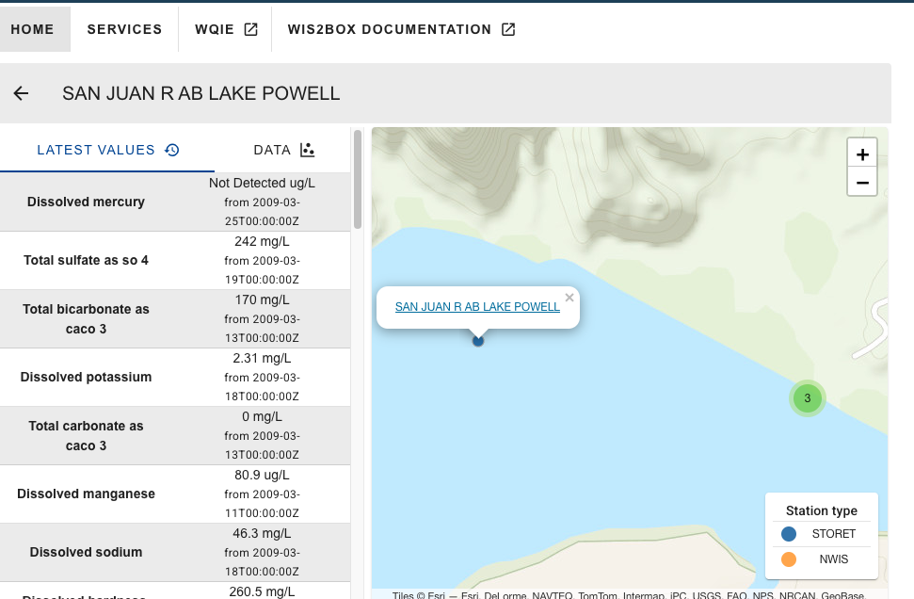

Figure 41 – example WQ IE data integration in US Internet of Water HubKit in a box tool.

## France

### In situ surface water quantity

French national specifications for Surface water quantity were easily mapped to the recommended practice. The mapping is available in “Annex H: French Sandre mapping to WQ IE.”

A dynamic ingestion mechanism from the national hydrological monitoring system (SCHAPI) was then set up to re-expose it according to the Water Quality IE recommendations.

Illustrations of such reuse are available in the next section (11.2.2 “Ex situ Surface water quality”) as the example emphasizes on the co-visualization that becomes easier to achieve now that both surface quantity and quality national systems are exposed according to the same international standard.

Another illustration is available in section 11.6.1 “Across countries / organizations” - National (France) to International Organization (WMO’s WHOS), demonstrating the possibility to connect external system to the national monitoring one thanks to the use of standards.

### Ex situ Surface water quality

French national specification for Surface water quality was successfully mapped to the recommended practice. That information is available in “Annex H: French Sandre mapping to WQ IE.” This allowed to expose the national surface water quality database ‘Naïades’ accordingly

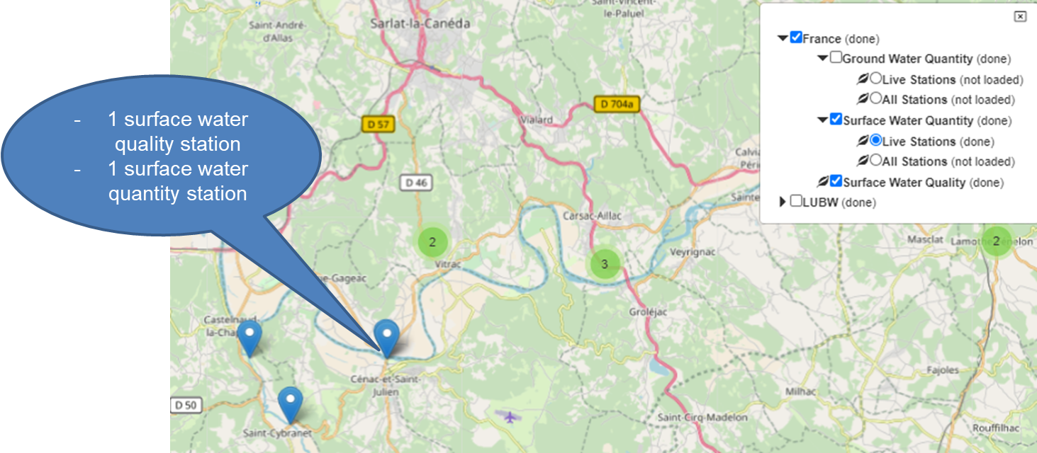

Figure 42 – 2 French surface water in-situ water quantity and ex-situ water quality stations on the Dordogne river

Each station datastream is then accessible.

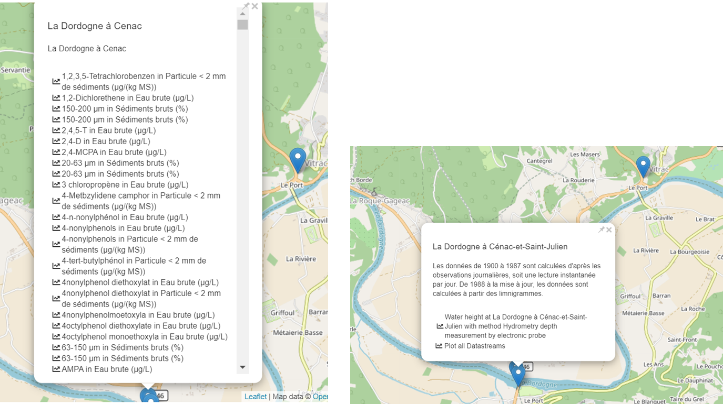

Figure 43 – Accessing the available datastreams of twoFrench surface water in-situ water quantity and ex-situ water quality stations on the Dordogne river

This allows access to the corresponding timeseries.

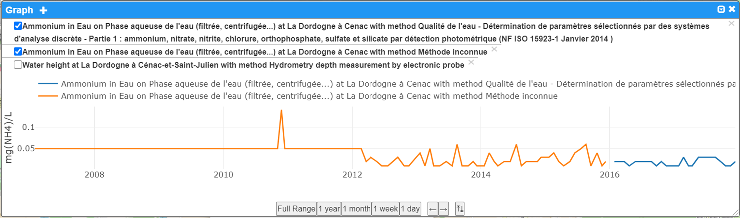

Figure 44 - Surface Water Quality Ex-Situ readings at “La Dordogne à Cenac” station

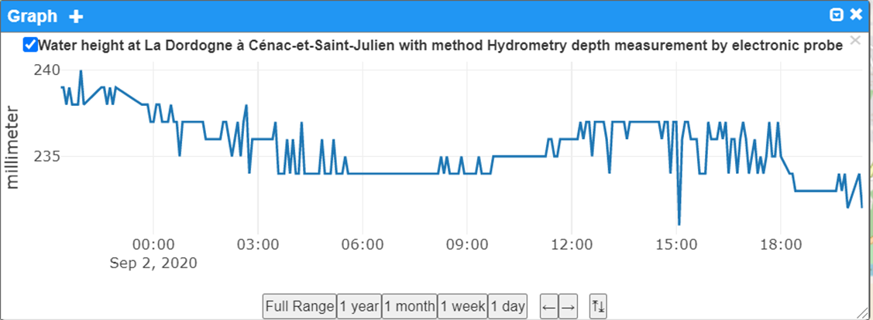

Figure 45 -Surface Water In-situ Quantity readings at “La Dordogne à Cénac et Saint-Julien Station”

### In situ ground water quantity and quality

French national geological survey (BRGM) sensors data was mapped to Observations, Measurements, and Samples and also SensorThings API as recommended by the Water Quality IE. This allows new readings to be pushed regularly to a SensorThings API instance. Ground water level sensors on the fields are also fitted with temperature and conductivity probes which allows measurement of both quantity and quality in-situ data.

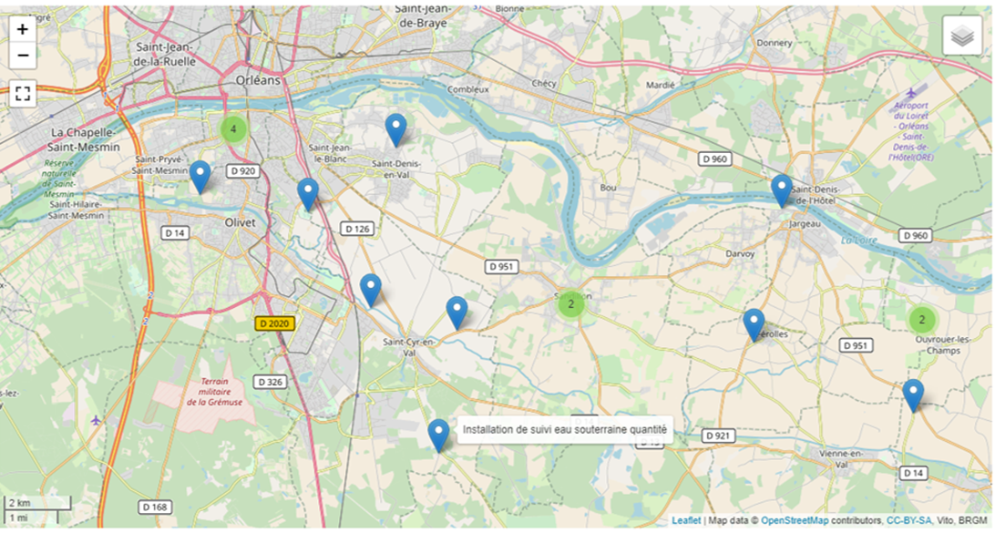

Figure 46 – GPRS Fitted Ground Water In-Situ Quantity and In-Situ Quality stations near Orléans

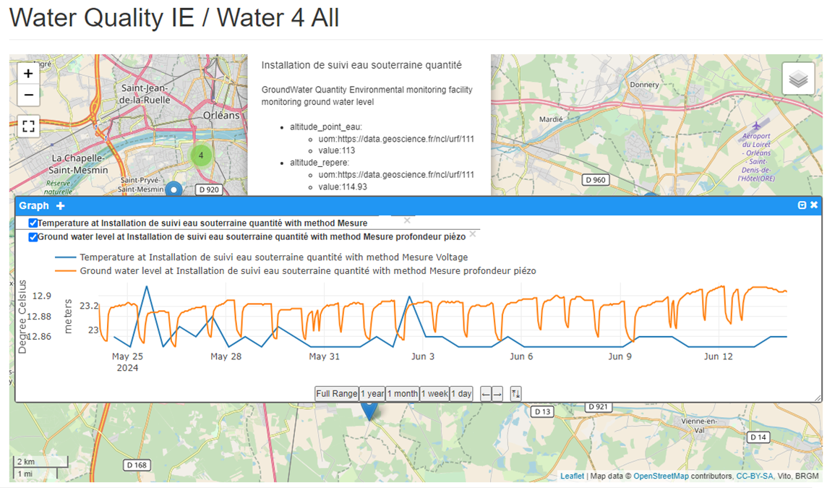

Figure 47 – Accessing Ground Water In-Situ Quantity and In-Situ Quality readings

Those raw data are then validated by experts allowing them to enter the national ground water database ‘ADES’. The national database structure respects the French national water information system specification. Mapping information from the national information model is available in “Annex H: French Sandre mapping to WQ IE.” It was not feasible during the WQ IE to plug the same system to the ADES production system. That effort continues after the WQ IE.

### Ex situ Ground water quality

The national specification for ground water quality was mapped to OMS and SensorThings API.

This information is available in “Annex H: French Sandre mapping to WQ IE.”

It was not feasible due to temporary technical reasons to dynamically feed a SensorThings API instance compliant to the WQ IE recommendation from the national database. However, prototyping proved that there was no blocking element on the semantic side.

## UNEP - GEMS

The Global Freshwater Quality Database GEMStat provides scientifically-sound data and information on the state and trend of global inland water quality. As operational part of the GEMS/Water Programme of the United Nations Environment Programme (UNEP), GEMStat is hosted by the GEMS/Water Data Centre (GWDC) within the International Centre for Water Resources and Global Change (ICWRGC) in Koblenz, Germany.

Its system is based on a proprietary solution (KISTERS Wiski[3]) which internal model was successfully mapped to the proposed approach so that corresponding observations are exposed.

At the time of writing this report, the formal authorization to expose publicly the mapping from the internal proprietary solution to the proposed one was not received. When/if available it will be shared on the WaterQuality IE GitHub project along with the other ones.

## EU EEA

The proposed approach was tested on the EEA Waterbase - Water Quality ICM dataset.

As mentioned on the reference webpage, (<https://sdi.eea.europa.eu/catalogue/srv/eng/catalog.search#/metadata/fbf3717c-cd7b-4785-933a-d0cf510542e1> ) *Waterbase is the generic name given to the EEA's databases on the status and quality of Europe's rivers, lakes, groundwater bodies and transitional, coastal and marine waters, on the quantity of Europe's water resources, and on the emissions to surface waters from point and diffuse sources of pollution*.

To test the approach, WISE SoE - Water Quality (WISE-6[4]) water quality reporting structure[5] was mapped to OMS and SensorThings API 1.1 (with Water Quality extension). The mapping is available in “Annex I: EEA WISE SoE mapping to WQ IE.”

The mapping was simplified as the data structure is close to OMS. While the provided data was not structured in accordance with OMS, enough of this underlying structure was retained in the simplified formats to allow for simple transformations.

This allowed for downloading data from EEA waterbase and loading it programmatically in a FROST server (ST API 1.1 + WQ IE extension enabled).

Data was then easily accessible from the SensorThings clients.

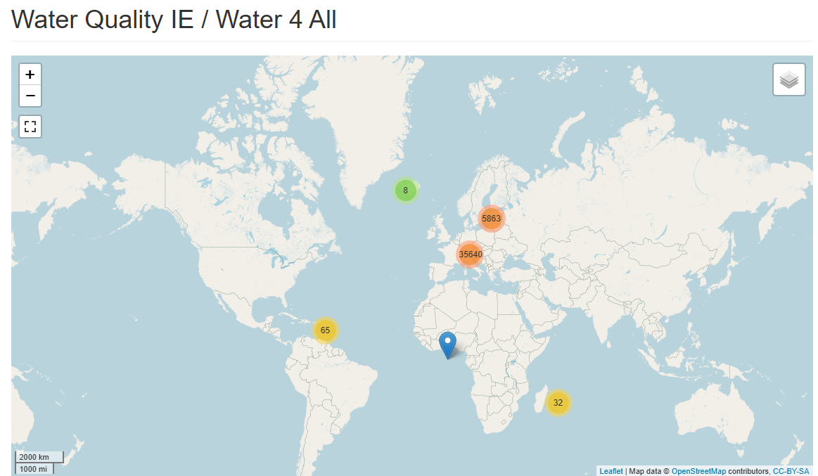

Figure 48 – Overview of EU EEA WISE SoE - Water Quality (WISE-6) exposed using WQ IE recommendations

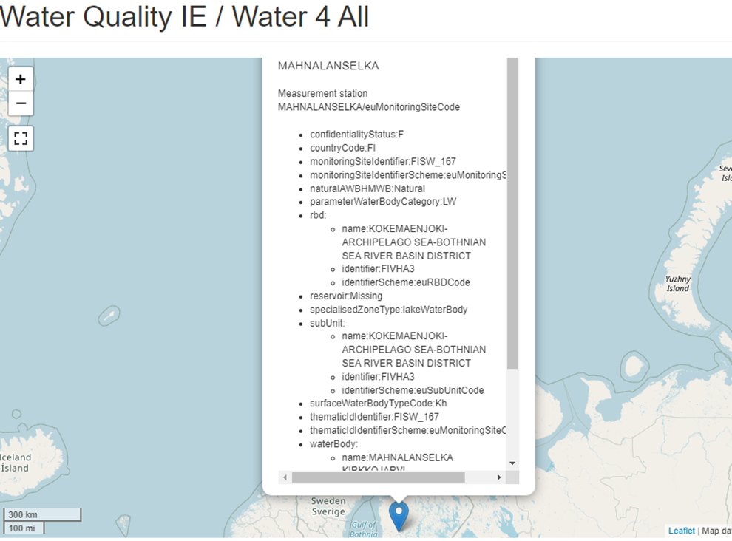

Figure 49 – Accessing a station description from EU EEA WISE SoE - Water Quality (WISE-6) using WQ IE approach

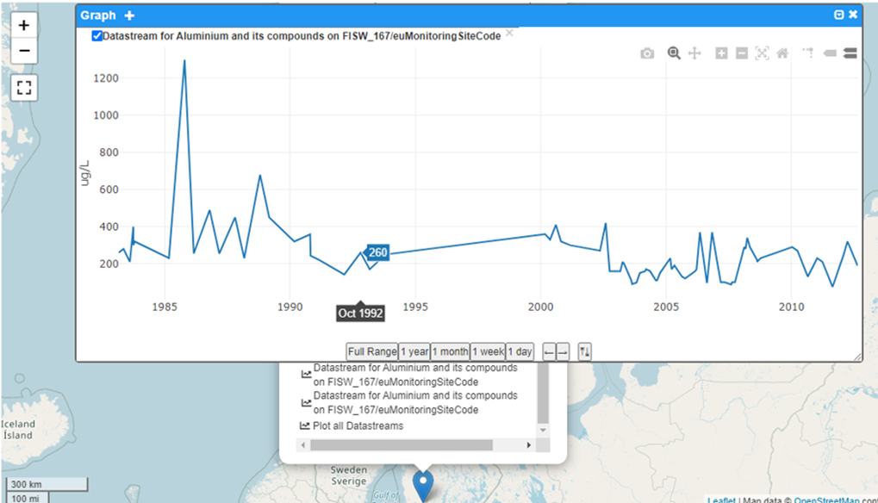

Figure 50 – Accessing a observations from a EU EEA WISE SoE - Water Quality (WISE-6) reported station using WQ IE approach

The next planned phase of activity for EU EEA includes:

* Refinement of the mapping around some side identified issues (ex link to biota, matrix, etc.); and
* allowance to traverse to more information regarding water bodies and also watersheds (EU River Basin Districts and SubUnits) directly from the station and Observation content. This will provide finer description of the ultimateFeatureOfInterests.

## Water4All members testing

Members from the EU Water 4All partnership[6] have been able to apply the Water Quality IE proposed approach on their national/organizational data. The same test/viewer environment was also shared between WaterQuality IE and Water4all projects.

These tests included the following.

* Danish Environment Portal (Danmarks Miljøportal): data on pollutants in water from the Vanda database.

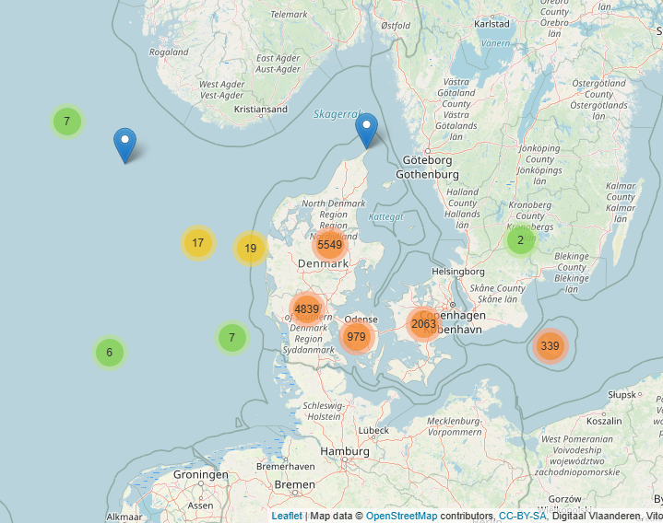

Figure 51 – Danish Environmental Portal water quality/quantity stations

* Italian Institute for Environmental Protection and Research (ISPRA) on a pesticide concentration in water data set.

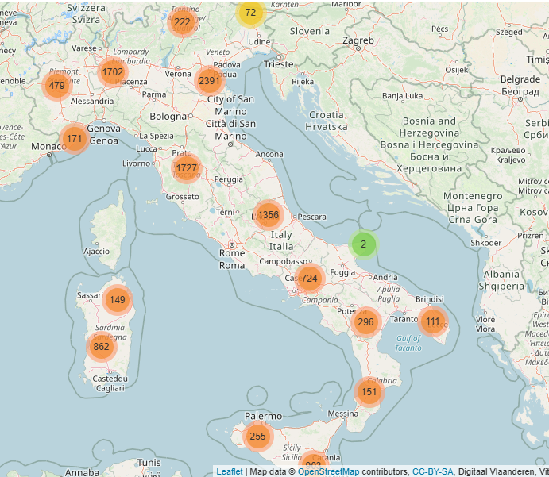

Figure 52 -ISPRA water surface water Ex-situ quality stations (pesticide database)

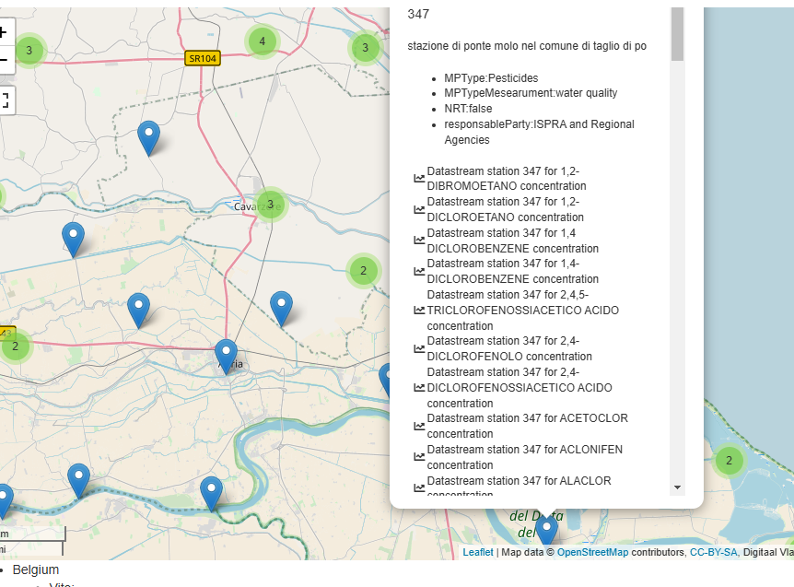

Figure 53 – Available Datastreams at one Surface water quality Ex-Situ station from ISPRA’s pesticides database

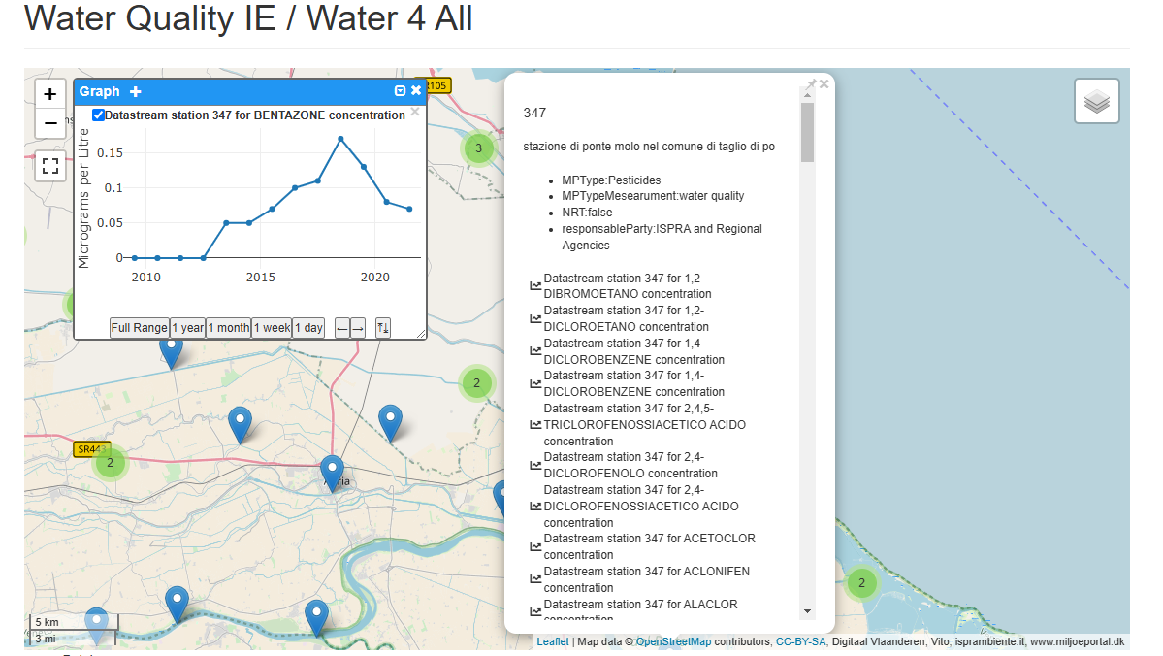

Figure 54 – Bentazone concentration evolution at a given Surface water Ex-Situ quality station

Bentazone observedProperty being exposed at ISPRA’s SensorThings API endpoint points back to the ontology used within the organization : <https://semscout.istc.cnr.it/whow/lodview/controlled-vocabulary/chemical-substances/cas-25057-89-0>

* German Data from the Länd Baden-Württemberg through Fraunhofer IOSB

Snapshots from those data are available in the next section 11.6.1 “Across countries / organisations” - “France-Germany test”.

* Belgian data through VITO on some test stations

## Cross-testing and data exchange

Cross testing was done across tools and countries/organizations

### Across countries / organizations

* + - 1. France-Germany test

French Water Information System surface water quality portal (Naïades) and German Länd Baden-Württemberg surface water quality data being exposed according to the Water Quality IE recommendations it was then feasible to access such data and have a cross-border view in a seamless manner.

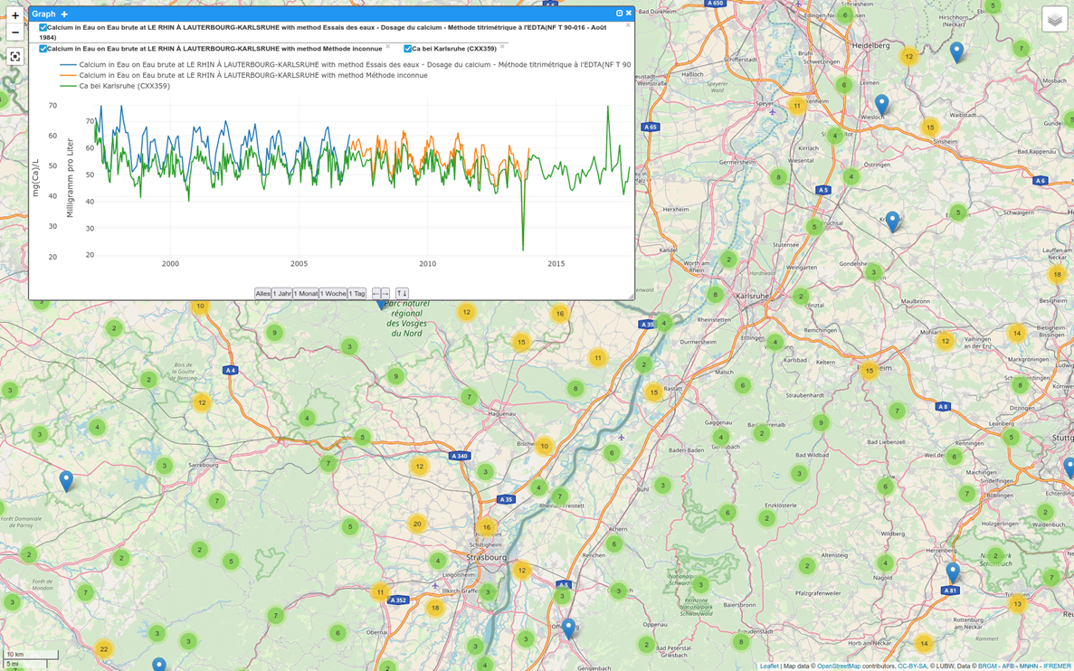

Figure 55 - French and German Surface water Ex-situ Quality stations on both sides of the Rhine river

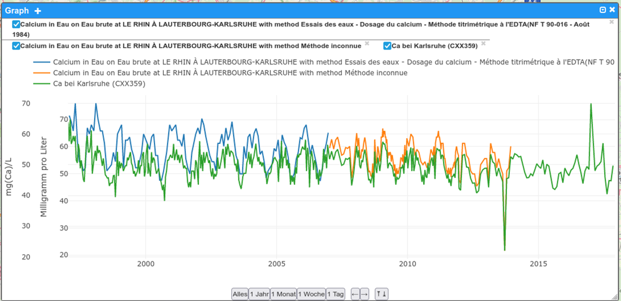

Figure 56 – Accessing Datastreams about the same observerdProperty at nearby French and German stations

This also proved that though one major step was done thanks to those practices another one remained in the need to align/link the various vocabularies used in the organizations as illustrated below.

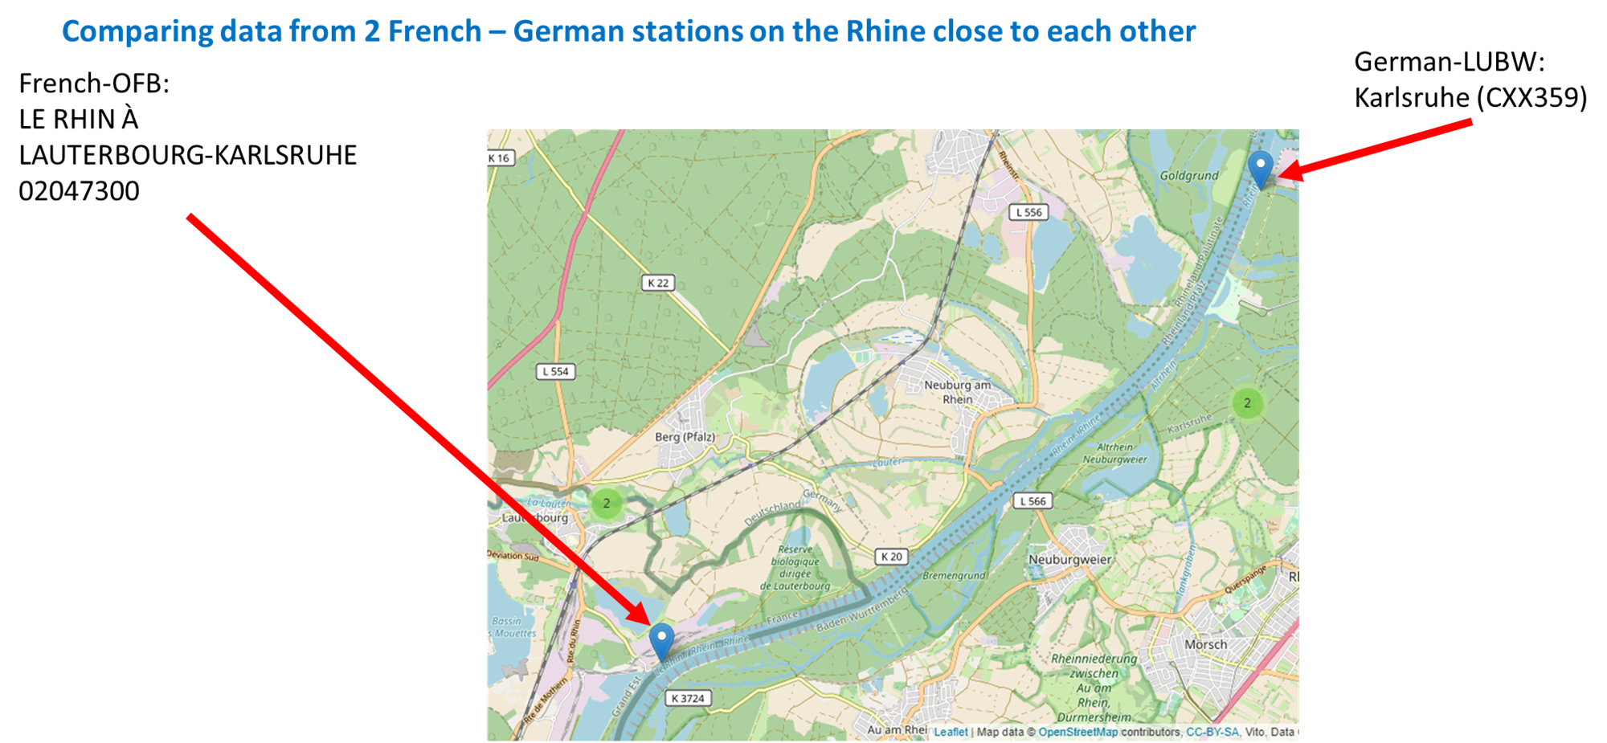

Figure 57 – Two French and German Surface water Ex-Situ quality stations of interest

Indeed, thanks to the approach tested in the Water Quality IE it is now possible to access in an interoperable/FAIR approach to stations from those two providers and also their respective ObservationCollections, Features of Interest etc. However, identifying stations measuring the same observable property still requires an important expertise (based on labels so far).

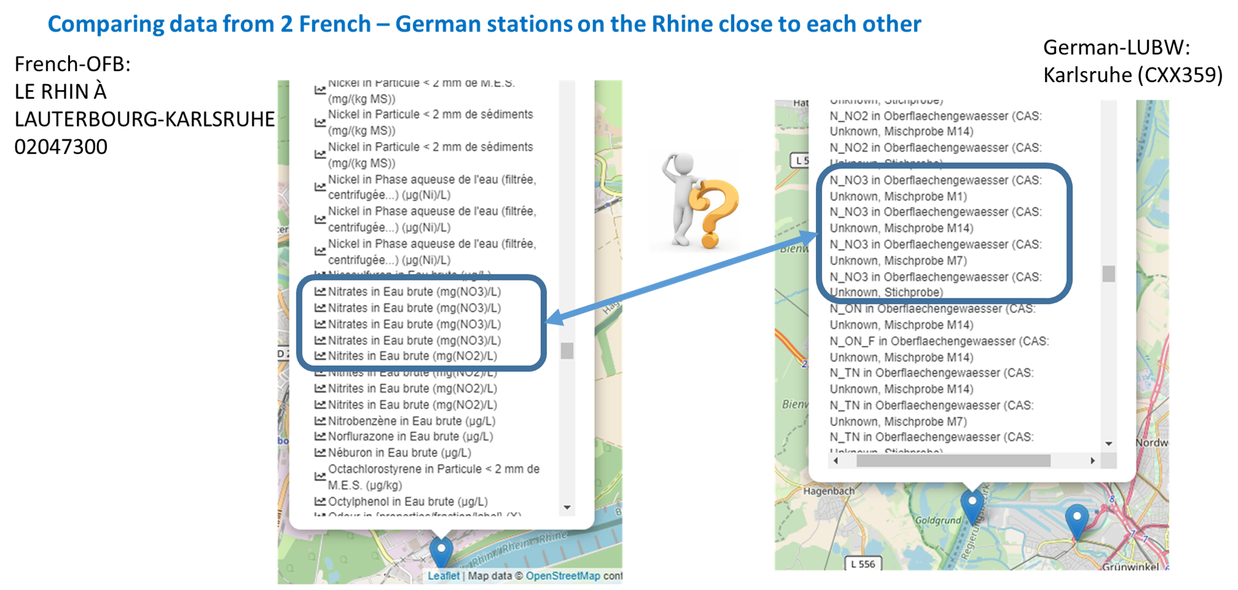

Figure 58 – Illustrating the need to align/link vocabularies across organisations (Nitrate example)

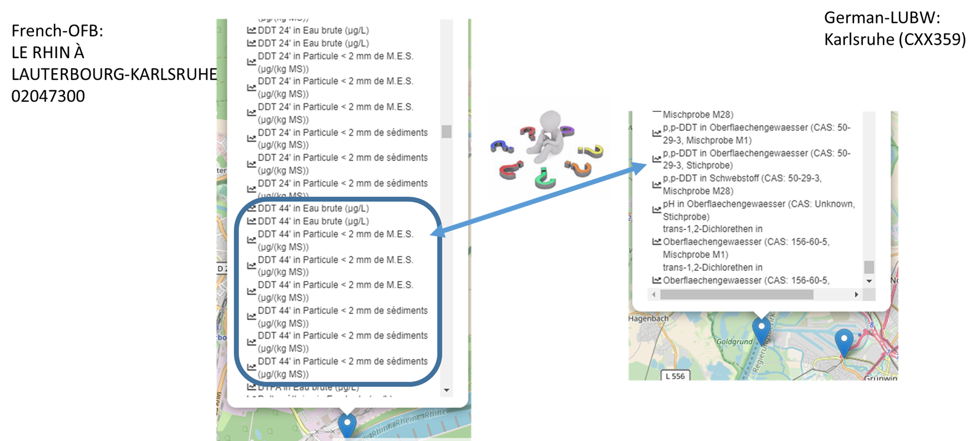

Figure 59 – Illustrating the need to align/link vocabularies across organizations (DDT example)

Internationally agreed upon best practices and how to expose those water quality vocabularies with the relevant semantics and also point to them from APIs exposing the corresponding observations is a work in progress that started within this IE; however more in-depth and dedicated work is needed to stabilize the approach.

During the I-ADOPT workshop February 20-21st, that use case was considered. It is available in “Annex I: I-ADOPT Fresh Water Observable properties.”

* + - 1. National (France) to International Organization (WMO’s WHOS)

French Water Information System surface water quantity data (SCHAPI) now being exposed according to the Water Quality IE recommendations, it was feasible for the World Meteorological Organisation team working on WMO Hydrological Observing System (WHOS)[7] to connect and ingest that information into WHOS.

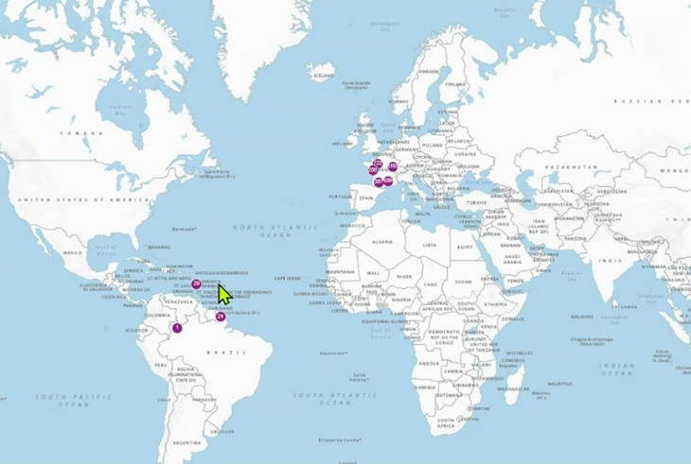

Figure 60 – French Surface water In-Situ quantity in WHOS

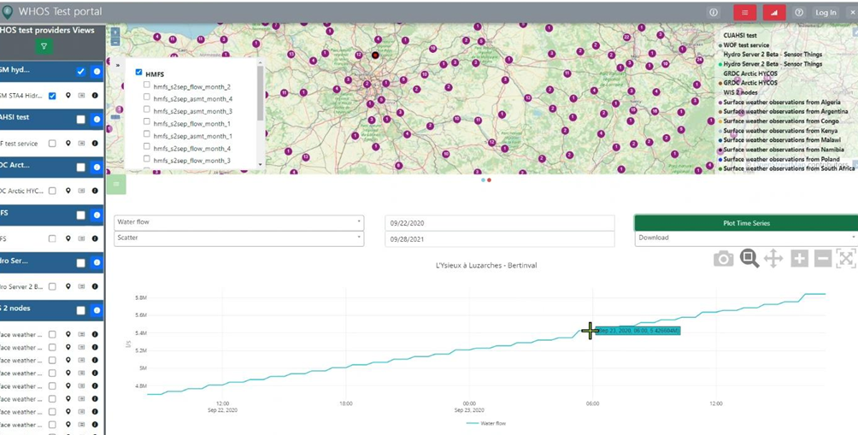

Figure 61 – Accessing readings from a French Surface water In-Situ quantity station in WHOS

The same operation was done for in-Situ Groundwater quantity/quality sensors.

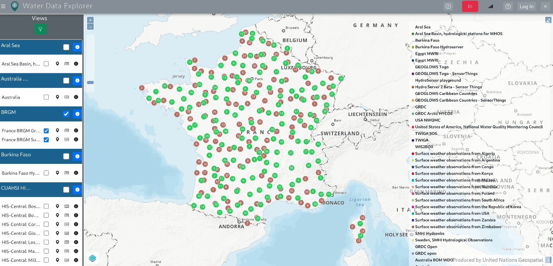

Figure 62 – French Ground and Surface water In-Situ data in WHOS

The feedback from the WHOS team regarding that exercise confirm the feasibility of the approach.

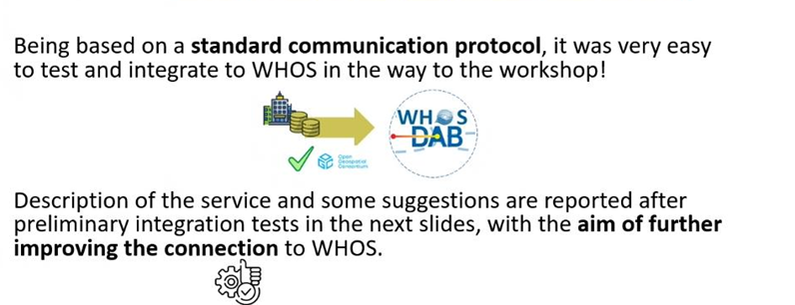

Figure 63 – WMO feedback on the feasibility to connect to French data using the WQ IE recommended practices during a WMO workshop

### Across tools

Connection to Water Quality IE compliant endpoints was tested from various tools to ensure the tested approach achieved interoperability.

* + - 1. Webclients

Fraunhofer WebGenesis[8] was used as the focal point for the WaterQuality IE and Water4All work. This generic SensorThings API webclient was able to connect generically to the endpoints set up by the various partners of the exercise with no ad-hoc hardcoding.

As such, connecting to either US or German data is just a matter of connecting to another SensorThings endpoint.

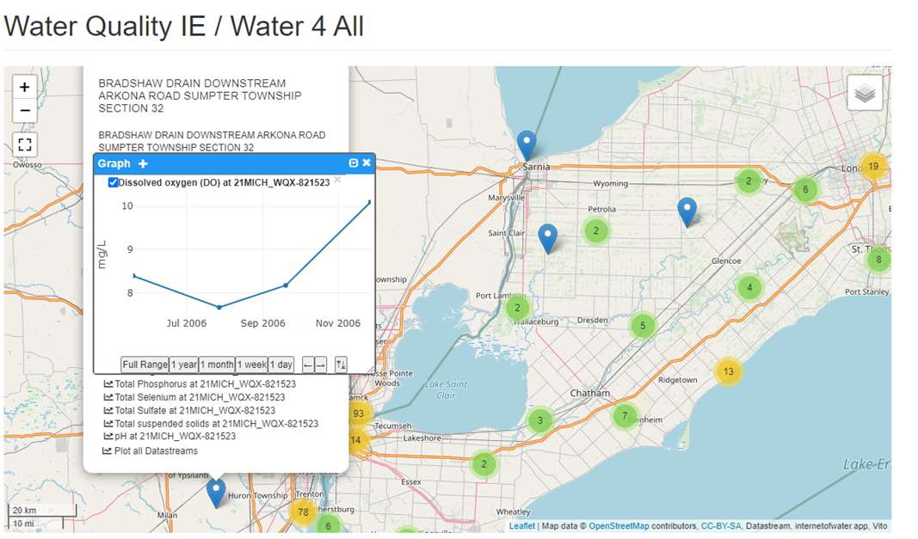

Figure 64 – Surface water quality data US - Canada, Great Lakes region in WebGenesis

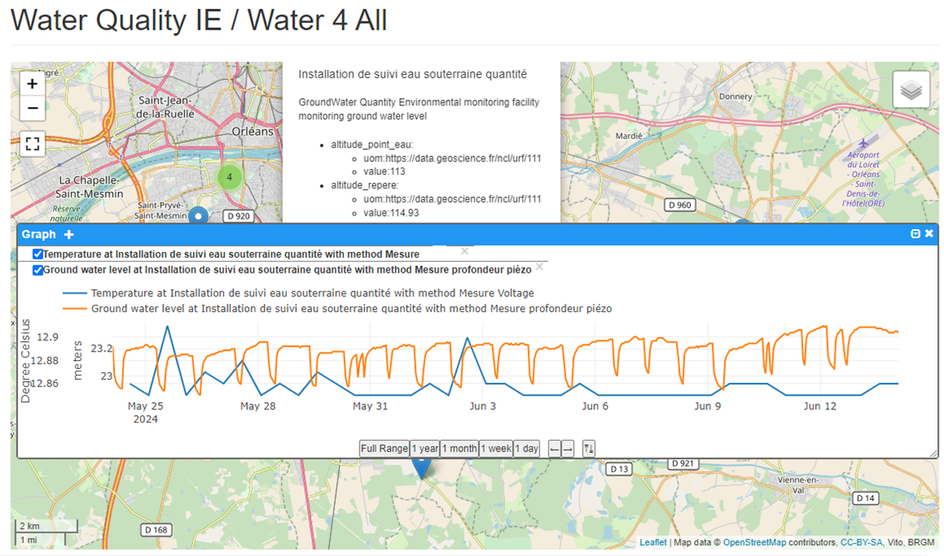

Figure 65 – French data: raw in-situ groundwater quantity & quality in WebGenesis

Other types of web clients were deployed such as the one developed by the US Internet of Water [HubKit in a box - Home](https://wqp.wqie.internetofwater.app/).

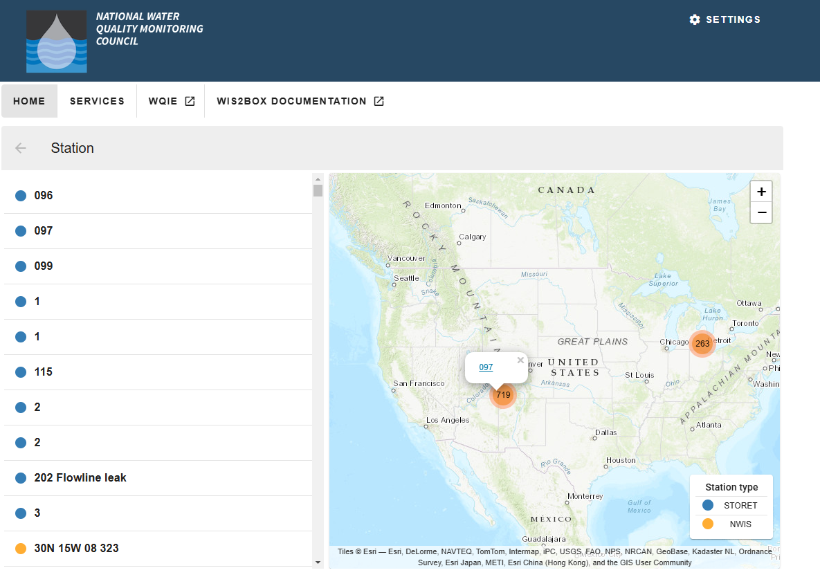

Figure 66 – Accessing WQ IE selected North America test regions stations in US Internet of Water tool

* + - 1. QGIS Client

The native SensorThings support for SensorThings API in QGIS core was funded[9] alongside the Water Quality IE thanks to the Water4all and OneWater Data[10] Projects.

Above version 3.36, QGIS core is now able to handle vanilla SensorThings API Part 1 V 1.1. Combined with the QGIS SensorThings API plugin[11] for rendering and querying, this allows a first use of data made available according to Water Quality IE recommendations.

As such, using the same French and German data as the one already used above, it is already possible to access the various water quality stations and access the corresponding timeseries.

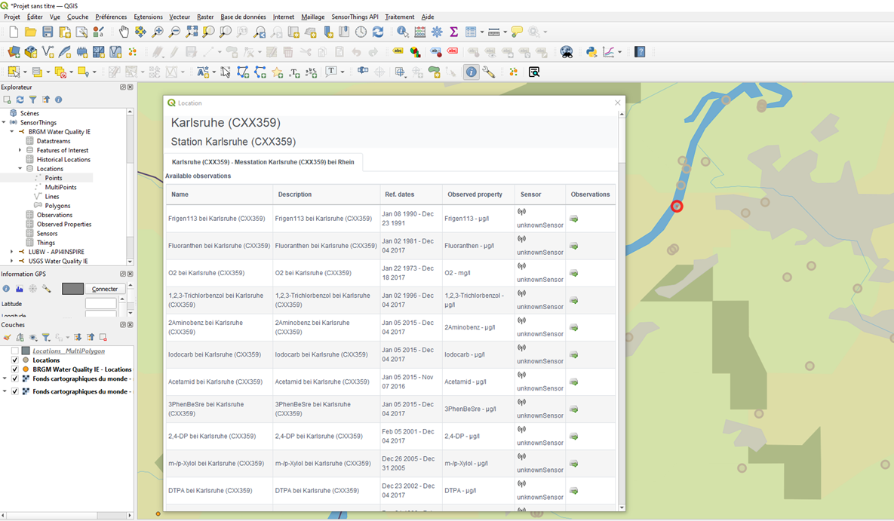

Figure 67 – Accessing available DataStreams from one German Surface Water Ex-Situ Station in QGIS

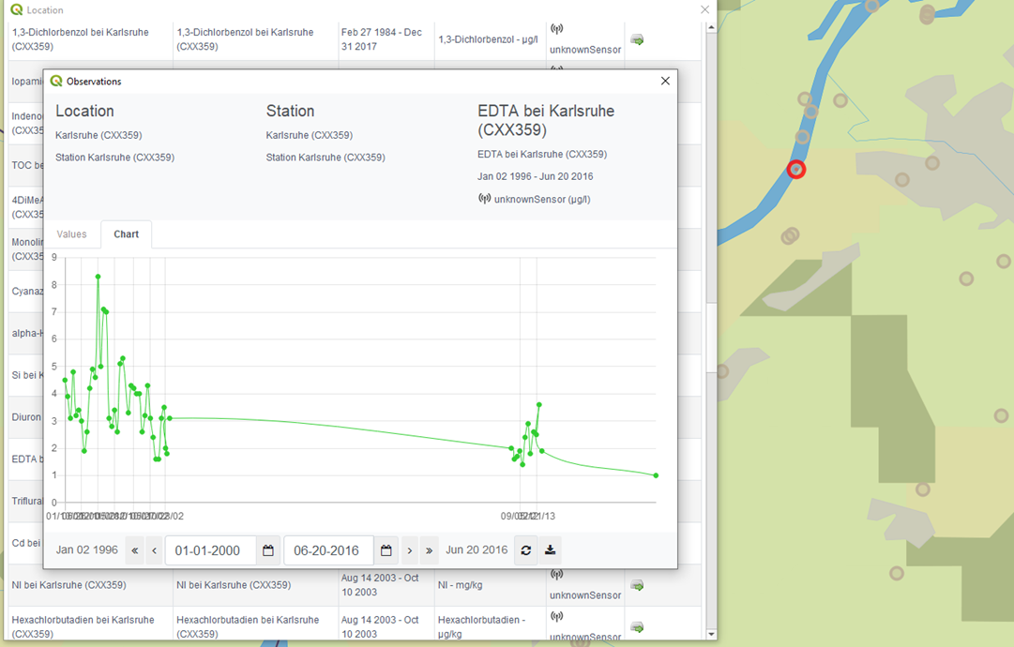

Figure 68 – Accessing available Observations from one German Surface Water Ex-Situ Station in QGIS

When SensorThings V2.0, taking into account Water Quality recommendations, is released the QGIS integration will be upgraded accordingly.

* + - 1. R Studio

RStudio IDE (or RStudio) is an integrated development environment for R, a programming language for statistical computing and graphics[12]. Connection from R Studio to US data exposed according to the Water Quality IE recommendations was also tested.

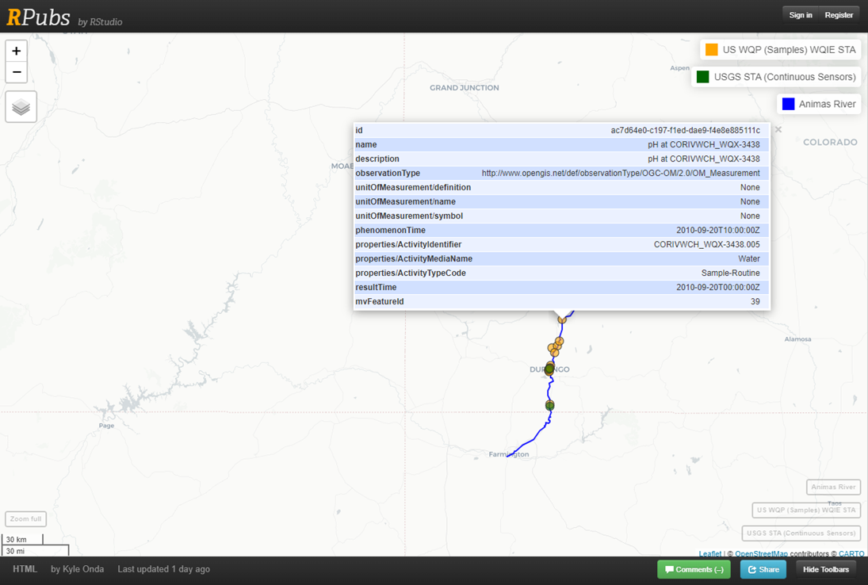

Figure 69 - Accessing USGS and US WQP stations through WQ IE recommendations in R studio

# Findings and standing issues

## Findings

The various implementations and testing described above prove that applying Water Quality IE recommendations solves several interoperability issues raised by the community in the identified Use Cases building only on the OGC Baseline for:

* Semantic interoperability: building on OGC Observations, Measurements, and Samples plus OGC Hy_Features and GroundWaterML2 for Water Geospatial data; and
* Technical interoperability: building on SensorThings API Part 1: Sensing

The implications are as follow.

* There is no need to fall into the ‘yet another standard’ rabbit hole but rather communicate, train, document, tool etc… to accompany the use of the baseline for Water Quality needs. This explains why there is a relatively small number of conceptual models done in the IE and a larger focus on Object Diagramming and Physical implementation work (ex: SensorThings API).
* The national/organization ad-hoc model to map to the identified baseline which is also an important element regarding adoptions of the Water Quality IE work.

As such, one of the first findings of the exercise was that transferring knowledge of the OGC baseline is a pre-requisite for an efficient joint work to happen. Having OMS and SensorThings API training material available at hand from the OGC side would be highly valuable.

Testing across tools and countries helped shape the Water Quality IE recommendations though more testing on the Sampling part need to take place.

This joint work allows to pave the way for SensorThings API to become fully OMS compliant in its V2.

Bottom line: It works ! 🙂

Still, there are remaining use cases and standing issues to enable a complete coverage of the Water Quality domain.

## Standing issues

On the domain side, as stated in section 6 “Use cases”, several use cases have been excluded from a first Water Quality IE.

Work on the greyed zone in the table below is required.

|  |  |  |  |  |
| --- | --- | --- | --- | --- |
| *Observed Property group* | Quantity | Physical properties | Chemistry | Biology |
| In situ sensor | WQ IE 1 | WQ IE 1 | WQ IE 1 |  |
| Ex situ (lab analysis) |
| Models |  |  |  |  |
| Remote |  |  |  |  |

On a more technical side, the standing issues are described in Water Quality IE GitHub (<https://github.com/opengeospatial/WaterQualityIE> ).

Some of them can be put forward in this report such as the following.

Water vocabulary alignment & sharing was not approached in the exercise. Indeed as demoed in section 11.6.1 “Across countries / organisations” - “France-Germany test”, ultimate FAIR data sharing will only be achieved when it is feasible to query a water observation data endpoint using shared or aligned vocabularies. Advancing that topic was initiated during two I-ADOPT workshop early 2025. More details about this is available in “Annex I: I-ADOPT Fresh Water Observable properties”.

When it comes down to referencing the River, Lake, Aquifer that is being monitored, it turns out that several hydro standards from the WaterML2.0 line are missing in the OGC definitions server to support Hydro Features typing as described in section 9.3 “SensorThings API deployment recommendations” - ”Reference to domain features”.

Several endpoints have extended the SensorThings API 1.1 + Water Quality IE extension model using the Properties (JSON Object) from the model which is perfectly valid. However, taking a closer look at the added properties, there is a need to define patterns on how to extend those properties so that the added key/value are also machine actionable. That topic was discussed but not with enough time to properly settle on the recommended mechanism.

## Impact on external standards

This Water Quality IE has impact on the following standards.

Teaming up the OGC Geotech IE, that exercise helped shape the current update of OGC SensorThings API 1.1 Part 1 into its draft V2. Allowing it to be Observations, Measurements and Samples compliant adds several important elements for the WaterQuality domain (ex: the entire Sampling, Sample part).

It also proves the feasibility of exchanging Water timeseries in an OMS compliant way using SensorThings API and simplifying the ingestion of this type of data into various system (ex: WHOS in section 11.6.1 “Across countries / organisations” - “National (France) to International Organization (WMO’s WHOS) “). This test is crucial as, since the original specification of OGC® WaterML 2.0: Part 1- Timeseries, many organizations have switched off their OGC Sensor Observations Services and replaced them by OGC SensorThings API Part 1 compliant ones.

Along that same line, the revision of OGC “Timeseries Profile of Observations and Measurements” (OGC 15-043r3, a.k.a Timeseries ML) is necessary since that version of the standard is based on Observation & Measurements and needs now to incorporate OMS. There is now a clear domain need to trigger that revision as, historically, OGC WaterML 2.0: Part 1- Timeseries was generalized into TimeseriesML. Now is the time for 1°/ an update and cleanup of the guidelines on how to share Timeseries data in a domain neutral manner and 2°/ clarify whether there is a need to document the necessary practice in the field of water.

Upon completion of the above work, the next proposed efforts are:

* Timeseries ML being OMS compliant,
* OGC WaterML 2.0: Part 1- Timeseries aligned with Timeseries ML revision, and
* SensorThings API 2.0 released.

The current “WaterML-WQ – an O&M and WaterML 2.0 profile for water quality data” will be able to be updated and a WaterML 2.0 Part 5 on water quality will be generated to officially stabilize water quality data exchange.

Eventually, sharing the same data according to semantic web standards (W3C SSN/SOSA[13]) was also prototyped at the very end of the WQ IE between the WQ IE and SSN/SOSA teams members. This work is also shared on the Water Quality IE GitHub and should ultimately be also exposed as an example in the revised SSN/SOSA (ongoing work).

# Conclusions

This IE was long due for the Hydro Domain Working Group and the overall water community.

Building on the important momentum around water data exchange globally it allowed to make significant progress in that domain and, important finding, building mainly on the current OGC baseline (semantics and APIs).

Following the Water Quality IE recommendations, interoperability across various organizations, tools and within various use cases was tested and proved feasible and useful.

Some standing issues remain but when the identified standards evolutions are done, the water community will have a solid international foundation to build on. It is also important to mention that, at the time of writing that ER, the revision of “Timeseries ML” and “OGC WaterML 2.0: Part 1- Timeseries” have already started building on the momentum from the IE.

SensorThings API revision into its V2 is also well on its way. On the tooling side, several organizations involved in the field of water have already switched to SensorThings API in its current version (1.1). This means that when SensorThings 2.0 is available they will already be in a good situation to move to the practices explored and advised in that engineering report.

A clear standardization and implementation roadmap is then delineated.

Roadmap that also needs to take on-board the use cases that were not covered by the current exercise. A Water Quality IE n°2 could cover those extra use cases and also more work to happen on sharing vocabularies.

# Acknowledgments

BRGM contribution to the Water Quality IE was possible thanks to funding from the French OneWater National Water Research Programme (grant 22-PEXO-0009, France 2030) and EU Water4All partnership programme.

DataStream Initiative's participation in the Water Quality IE was made possible through support from The Gordon Foundation.

BMUV funding supported UNEPS-Gems Water Data Center participation in the WQ IE.

# Acronym table

|  |  |
| --- | --- |
| ADES | Accès aux Données sur les Eaux Souterraines |
| API | Application Programming Interface |
| BRGM | Bureau de Recherches Géologiques et Minières (French Geological Survey) |
| EEA | European Environment Agency |
| GEMS | Global Environment Monitoring System (UNEP) |
| IE | Interoperability Experiment |
| ISPRA | Istituto Superiore per la Protezione e la Ricerca Ambientale |
| OFB | Office Français de la Biodiversité (French Biodiversity Office) |
| OMS | OGC/ISO ISO 19156:2023: Observations, Measurements and Samples |
| O&M | OGC/ISO 19156:2011: Observations & measurements |
| LUBW | Land Baden-Württemberg |
| STA | OGC SensorThings API Part 1: Sensing Version 1.1” (OGC 18-088) |
| SCHAPI | Service central d'hydrométéorologie et d'appui à la prévision des inondations (SCHAPI) |
| UNEP | United Nations Environment Programme |
| UNESCO | United Nations Educational, Scientific and Cultural Organization |
| USGS | United States Geological Survey |
| WQ IE | Water Quality IE |
| WHO | World Health Organization |
| WHOS |  |
| WISE | Water Information System for Europe |
| WMO | World Meteorological Organization |
| WQP | US Water Quality Portal |
| WQX | Water Quality eXchange schema |
| WWQA | World Water Quality Alliance |

# Annex A: other examples of Surface Water In-situ Quantity Use Case

In-Situ sensor

|  |  |
| --- | --- |
| USGS stream gage 10242000 Coal Creek near Cedar City, Utah | [USGS stream gage 10242000 Coal Creek near Cedar City, Utah | U.S. Geological Survey](https://www.usgs.gov/media/images/usgs-stream-gage-10242000-coal-creek-near-cedar-city-utah) |
| A USGS hydrologic technician installs a Rapid-Deployment Gauge on a bridge in Norfolk, Virginia. | [A USGS hydrologic technician installs a Rapid-Deployment Gauge | U.S. Geological Survey](https://www.usgs.gov/media/images/a-usgs-hydrologic-technician-installs-a-rapid-deployment-gauge) |
| View of Cement Creek from USGS gage 09358550 | [Cement Creek near CC48 | U.S. Geological Survey (usgs.gov)](https://www.usgs.gov/media/images/cement-creek-near-cc48) |
| stream monitoring equipment in a small stream surrounded by woods | [Buck Creek Watershed | U.S. Geological Survey (usgs.gov)](https://www.usgs.gov/media/images/buck-creek-watershed) |
| Bridge, showing USGS bridge-mounted stream sensors | [Streamgage at Trinity River near Rosser | U.S. Geological Survey (usgs.gov)](https://www.usgs.gov/media/images/streamgage-trinity-river-near-rosser) |
| Image: Installing Water-Level Monitoring Gage | [Installing Water-Level Monitoring Gage | U.S. Geological Survey (usgs.gov)](https://www.usgs.gov/media/images/installing-water-level-monitoring-gage) |
| USGS stream gage 14314500 Clearwater River above Trap Creek near Toketee Falls, OR. | [USGS stream gage 14314500 Clearwater River above Trap Creek, OR | U.S. Geological Survey](https://www.usgs.gov/media/images/usgs-stream-gage-14314500-clearwater-river-above-trap-creek-or) |
|  | Site / Station / Sensor in the French Water Information System |

Manual measurement

|  |  |
| --- | --- |
| Hydrologic Technician Matt Bach measures discharge in Ashwaubenon Creek near Little Rapids, WI | [Hydrologic Technician measures discharge in Ashwaubenon Creek, WI (2) | U.S. Geological Survey (usgs.gov)](https://www.usgs.gov/media/images/hydrologic-technician-measures-discharge-ashwaubenon-creek-wi-2) |
| Winter discharge at Fivemile Creek | [Winter discharge at Fivemile Creek | U.S. Geological Survey (usgs.gov)](https://www.usgs.gov/media/images/winter-discharge-fivemile-creek) |
| Hydrologic Technician admires the view while measuring discharge at the base of the South Cascade Glacier, WA | [Hydrologic Technician measuring discharge. South Cascade Glacier, WA. | U.S. Geological Survey (usgs.gov)](https://www.usgs.gov/media/images/hydrologic-technician-measuring-discharge-south-cascade-glacier-wa) |
| at river's edge, a laptop displays graphs (foreground) while a hydrologist wades in the water with equipment (background) | [Measuring Stream Discharge with Acoustic Doppler Current Profiler | U.S. Geological Survey (usgs.gov)](https://www.usgs.gov/media/images/measuring-stream-discharge-acoustic-doppler-current-profiler) |

# Annex B: other examples of Surface Water In-situ Quality Use Case

|  |  |
| --- | --- |
| Sensors are cleaned with an automatic wiper brush on the continuous water-quality monitors. | [Water-quality sensors kept clean for harmful algal bloom monitoring | U.S. Geological Survey (usgs.gov)](https://www.usgs.gov/media/images/water-quality-sensors-kept-clean-harmful-algal-bloom-monitoring) |
| Hydro techs inspecting water quality sensors at Cochiti Dam | [Hydro techs inspect water quality sensors | U.S. Geological Survey (usgs.gov)](https://www.usgs.gov/media/images/hydro-techs-inspect-water-quality-sensors) |
|  | Surface water quality campaign, Dordogne watershed – River flow measurement  © Hélène Bressan, EPIDOR |
|  | Surface water quality campaign, Dordogne watershed – conductivity, pH, Dissolved Oxygen sensors along with water Temperature measurement.  © Hélène Bressan, EPIDOR |

# Annex C: other examples of Surface Water Ex-situ Quality Use Case

|  |  |
| --- | --- |
| Taking a w​​​​​ater sample in Green River | [Taking a w​​​​​ater sample in Green River | U.S. Geological Survey (usgs.gov)](https://www.usgs.gov/media/images/taking-a-w-ater-sample-green-river) |
| The water quality sample is being taken at Saugatuck River near Westport, CT 01209500 | [Taking the water quality sample | U.S. Geological Survey (usgs.gov)](https://www.usgs.gov/media/images/taking-water-quality-sample) |
| ​​​​​​​Adam Sperry sampling water at Pine Creek | [Adam Sperry sampling water at Pine Creek | U.S. Geological Survey (usgs.gov)](https://www.usgs.gov/media/images/adam-sperry-sampling-water-pine-creek) |
|  | Surface water quality campaign, Dordogne watershed – preparing samples in the boat some needing to be put in an insulated ice box (the blue one)  © Hélène Bressan, EPIDOR |
|  | Surface water quality campaign, Dordogne watershed – grabing sampling from the bridge  © Hélène Bressan, EPIDOR |
|  | Surface water quality campaign, Dordogne watershed – sample preparation on the pier. On the bottom left corner are the 3 sensors pictured at the end of ‘Annex B: other examples of Surface Water In-situ Quality Use Case’  © Hélène Bressan, EPIDOR |

# Annex D: other examples of Ground Water In-situ Quality Use Case

|  |  |
| --- | --- |
| Groundwater-Level Measurement at Ellsworth Air Force Base | [Groundwater-Level Measurement at Ellsworth Air Force Base | U.S. Geological Survey (usgs.gov)](https://www.usgs.gov/media/images/groundwater-level-measurement-ellsworth-air-force-base) |
| Groundwater site inspection, Petersham, Massachusetts | [Groundwater site inspection, Petersham, Massachusetts | U.S. Geological Survey (usgs.gov)](https://www.usgs.gov/media/images/groundwater-site-inspection-petersham-massachusetts) |

# Annex E: other examples of Ground Water Ex-situ Quality Use Case

|  |  |
| --- | --- |
| Purging a domestic well to be sampled for radon | [Purging a domestic well to be sampled for radon | U.S. Geological Survey (usgs.gov)](https://www.usgs.gov/media/images/purging-a-domestic-well-be-sampled-radon) |
| eUSGS employee sampling a public supply well for water quality analysis | [USGS employee sampling a public supply well for water quality analysis | U.S. Geological Survey](https://www.usgs.gov/media/images/usgs-employee-sampling-a-public-supply-well-water-quality-analysis) |
| Groundwater Sampling, Glacial Ridge Refuge | [Groundwater Sampling, Glacial Ridge National Wildlife Refuge | U.S. Geological Survey (usgs.gov)](https://www.usgs.gov/media/images/groundwater-sampling-glacial-ridge-national-wildlife-refuge) |

# Annex F: WQX mapping to WQ IE

That document is available on the Water Quality IE Github: <https://github.com/opengeospatial/WaterQualityIE/tree/master/ER/AnnexF_WQX_mapping>

# Annex G: SensorThings API 1.1 + WQ IE extension payload example

The following payload corresponds to surface water quality data in the US "YELLOWJACKET CANYON NEAR MOUTH" (Colorado).

The complete payload and corresponding API query is available the Water Quality IE Github: <https://github.com/opengeospatial/WaterQualityIE/tree/master/ER/AnnexG_SensorThings_API_1.1_WQ%20IE_extension_payload_example> :

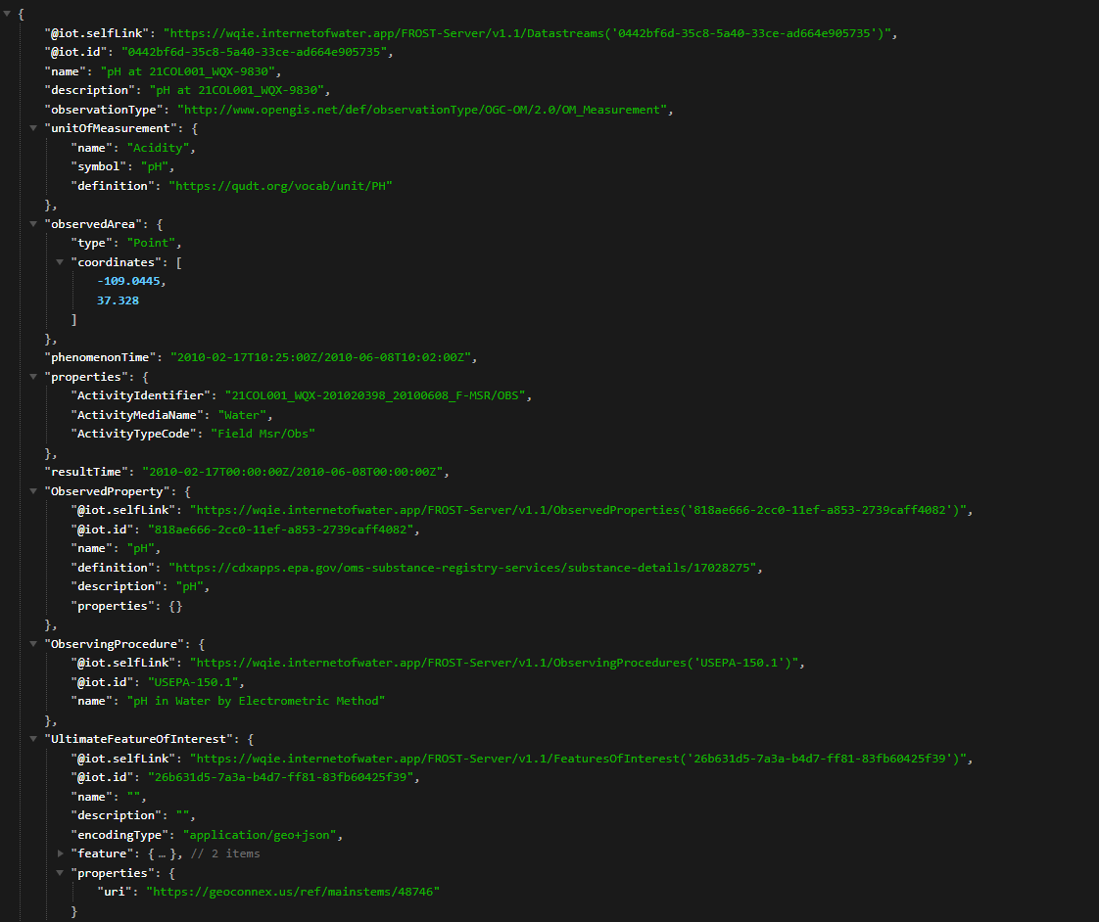

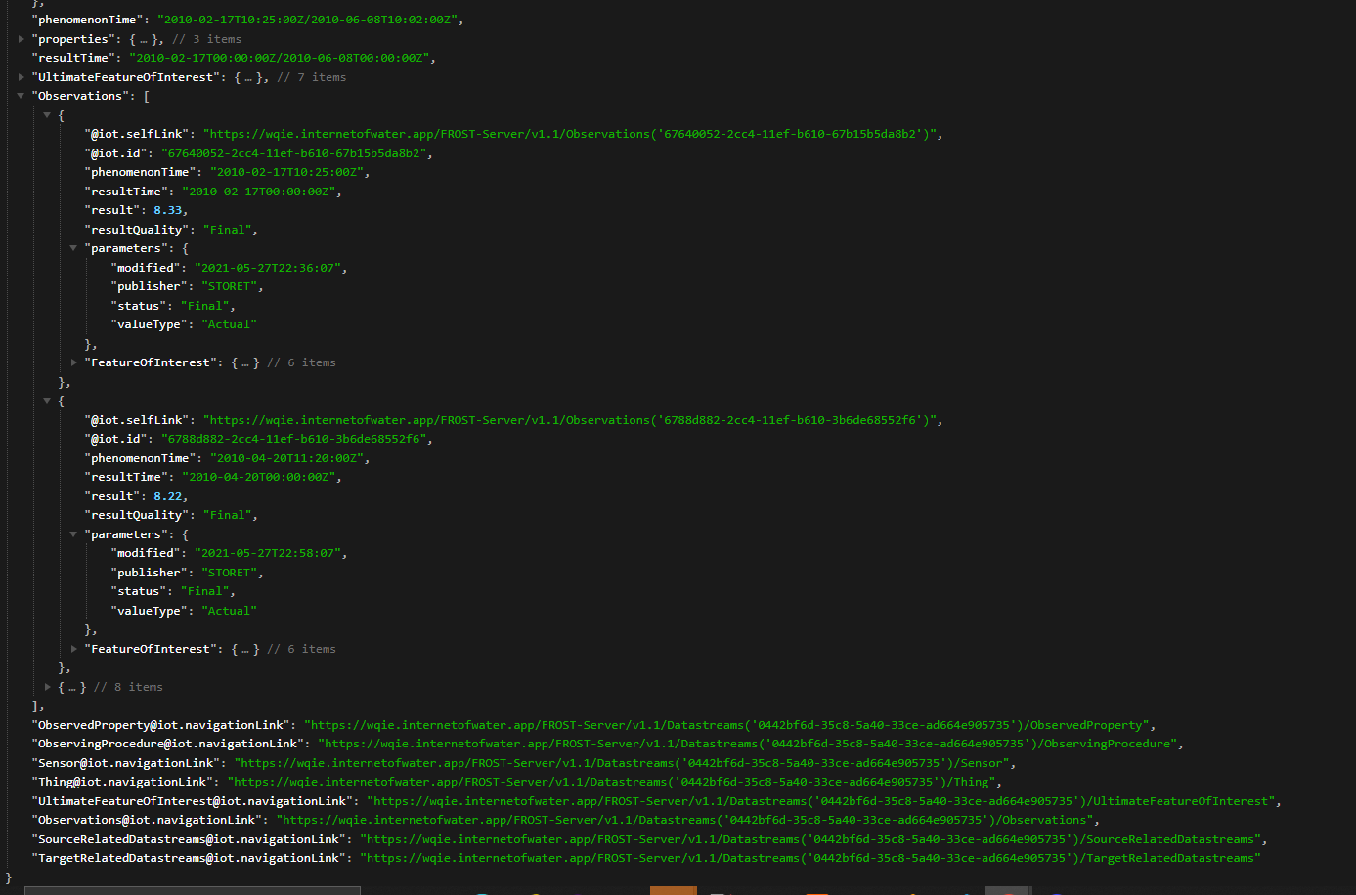

# Annex H: French Sandre mapping to WQ IE

## In-situ surface water quantity

That document is available on the Water Quality IE Github: <https://github.com/opengeospatial/WaterQualityIE/tree/master/ER/AnnexH_French_Sandre_mapping/In-situ_SurfaceWater_quantity>

## Ex-situ surface water quality

That document is available on the Water Quality IE Github: <https://github.com/opengeospatial/WaterQualityIE/tree/master/ER/AnnexH_French_Sandre_mapping/Ex-situ_SurfaceWater_quality>

## In-situ ground water quantity/quality

* + 1. Ground Water Quantiy in-situ

That document is available on the Water Quality IE Github: <https://github.com/opengeospatial/WaterQualityIE/tree/master/ER/AnnexH_French_Sandre_mapping/In-situ_GroundWater_quantity_quality>

* + 1. Ground Water Quality in-situ

Raw observations coming from GPRS sensors on the field are converted to an OMS compliant data structure which in turns feeds a SensorThings API server. Thus for raw in-situ quality data there is no mapping to be defined as already in the target semantic/structure.

However, at the time of writing the present report, there is no national specification for validated in-situ quality observation, thus awaiting for that international exercise to be wrapped-up and turned into an international Best Practice, the Ground Water ex-situ quality structure has been hacked (with a fake sampling) to allow data storage and work for domain colleagues.

## Ex-situ Ground water quality

That document is available on the Water Quality IE Github: <https://github.com/opengeospatial/WaterQualityIE/tree/master/ER/AnnexH_French_Sandre_mapping/Ex-situ_GroundWater_quality>

# Annex I: EEA WISE SoE mapping to WQ IE

That document is available on the Water Quality IE Github: <https://github.com/opengeospatial/WaterQualityIE/tree/master/ER/AnnexI_EU_EEA_WISE_SoE_mapping>

# Annex I: I-ADOPT Fresh Water Observable properties

That document is available on the Water Quality IE Github: <https://github.com/opengeospatial/WaterQualityIE/tree/master/ER/AnnexJ_I-ADOPT_Freshwater_observable_properties>

# Annex K: Water Quality IE Deployment Documentation

That document is available on the Water Quality IE Github: <https://github.com/opengeospatial/WaterQualityIE/tree/master/ER/AnnexJ_DeploymentDocumentation>

# Revision history

|  |  |  |  |  |
| --- | --- | --- | --- | --- |
| Date | Release | Editor | Primary clauses modified | Description |
| 0.1 | August 2024 | S.Grellet | All | First draft inception |
| 0.5 | Fall 2024 | IE Members | All | Group contribution |
| 0.9 | January 2025 | S.Grellet, IE Members | All | ER stabilization for WQ IE members comments |
| 1.0 | April 2025 | S.Grellet | All | Final ER for Public comment |

1. <https://www.unep.org/topics/sustainable-development-goals/why-do-sustainable-development-goals-matter/goal-6-clean-water>
2. <https://github.com/opengeospatial/sensorthings/blob/23-019/sections/clause_06_overview.adoc>
3. <https://www.kisters.eu/product/wiski/>
4. <https://cdr.eionet.europa.eu/help/WISE_SoE/wise6>
5. <https://dd.eionet.europa.eu/datasets/latest/WISE-SoE_WaterQualityICM>
6. <https://www.water4all-partnership.eu/>
7. <https://wmo.int/activities/wmo-hydrological-observing-system-whos>
8. <https://www.iosb.fraunhofer.de/en/projects-and-products/webgenesis.html>
9. <https://changelog.qgis.org/en/qgis/version/3.36/#sensorthings-data-provider>
10. <https://www.onewater.fr/en/projects/targeted-projects>
11. <https://plugins.qgis.org/plugins/SensorThingsAPI/>
12. <https://en.wikipedia.org/wiki/RStudio>
13. <https://www.w3.org/TR/vocab-ssn/>